Table of Contents

Table of Contents 2
Introduction 2
Key 4
Keywords 4
Existing Keywords 5
Keyword Research 5
Keyword Cannibalisation 7
Keyword Traffic Potential 8
On Page SEO 10
Page Titles 10
Meta Descriptions 13
OG Tags & Twitter Cards 18
H-Tag Heading Structure 20
Media, Images and Alt Text 23
Links & Siloing 29
Physical Siloing & URL Structure 29
Virtual Siloing & Linking 34
Anchor Text 38
On Page Content 40
Correlation Analysis 40
Content Length 42
Content Quality & Search Intent 43
Content Ideas 44
Short Form Evergreen Content 45
Long-form articles 45
Infographics 47
Guest Articles 48
List Posts 48
How to Guides 49
Roundups 50
Final thoughts on content creation 50
Content Promotion and Outreach Strategy 52
Link Creator Database creation 52
Social Media Promotion 53
PPC 53
Strategic Partnerships and existing authority sites 53
Manual & automated outreach 54
Summary and Conclusion 55
Areas for Improvement 55
Keywords 55
On Page SEO 56
Links 57
Content 58
Appendices 58

Introduction

A content audit is the process of evaluating existing content on your site to assess its quality and performance. It highlights what content should be deleted, redirected or improved.

We evaluate your on-page SEO to check that your pages are optimised for search engines in order to reach your target audience. While we do assess key metrics, a content audit is also more qualitative in nature. Understanding your target audience’s intent is crucial for SEO and any successful content strategy. It’s not just Google that looks at your content but your audience as well, and you have to cater to both.

We look at examples of your existing content and analyse them from an SEO perspective. We tell you what’s being done right and what can be improved.

The content audit also identifies any content gaps in terms of searched topics that you have not covered. There may also be relevant keywords that are currently ranking well that you could target - we provide you with lists of these relevant search terms and phrases to use going forward.

In these ways, the audit will help you and your team to better optimise or reuse existing content that may be performing poorly.

We also provide you with ideas and step by step guides for creating new content using frameworks that are working in SEO right now. And rather than taking a publish and pray approach, we suggest strategies for promotion and outreach to get your content seen and shared.

Key

Green - Done well / trivial room for improvement
Orange - Done poorly / room for improvements
Red - Current state is detrimental to overall SEO / completely unimplemented
Blue - Our recommendation

Keywords

In SEO, keywords range from single words to complex phrases that people use in search queries in Google or other search engines. The keywords in this section will inform many of your onpage SEO choices, which is why we deal with it first in this audit.
lKEYWORDSl

To understand why keywords are important, we must understand the 2 main metrics which Google considers when ranking pages:

- Authority
  - (This is dealt with in the Competitor Audit.)
  - It is primarily measured by the number of links that point to the page (it’s pretty simple: more backlinks = more authority).
  - The quality of the backlinks also matters. A single high quality backlink can be worth dozens of low quality backlinks.
  - Internal links also play a role in passing authority around the site.
- Relevancy
  - (This is dealt with in the Content Audit.)
  - It is measured by the types of pages which the page links to (e.g. a page titled “Cars” which links to IMDB and Rotten Tomatoes is probably talking about the movie, not the physical object).
  - It is also measured by other factors (such as keywords, titles, header structure, image alt text, and so on).

The goal is to make sure your pages have relevant keywords that people are searching for so that your site can better match the searcher intent. When effectively researched and optimised, keywords will help your page organically rank higher in search results and funnel your target audience to your website.

This section will assess the keywords you are currently targeting, consider the keywords you could be targeting, and investigate whether any of your pages are cannibalising each other and lowering search volume. Finally we assess the potential increase in traffic that you can expect from ranking better for certain keywords.


Existing Keywords
Our goal is to determine whether the current keyword targeting strategy is working. And, to find untapped keywords that could result in “easy” wins.

We need to examine your current set of keywords and then examine opportunity keywords.

Are you currently targeting the right keywords?

Often, the keywords that some businesses are going after are way out of their league. They think they can win on “homerun” keywords, but they will more than likely end up failing.

We need to determine whether you should target competitive keywords or go for medium tail or long tail keywords (variations of the keywords that are less searched but still get a lot of traffic when accumulated).

DATA COLLECTION

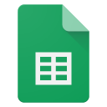 | Existing keywords
 | Top folders
 | Keyword intersect [your competitors have these keywords but you don’t]

FINDINGS

- Your site currently ranks for 173 keywords (global) and 67 keywords in the Bahamas
  - 60 keywords are ranking #1 in the Bahamas. These are all branded keywords.

Keyword | Location | Current position | KD | Volume
paradise games | Bahamas | 1 | 5 | 11000
pggames | Bahamas | 1 | 55 | 1900
paradise game | Bahamas | 1 | 39 | 1900
pg games.com | Bahamas | 1 | 81 | 2900
ppgames | Bahamas | 1 | 0 | 500
pgweb | Bahamas | 1 | 11 | 200
paradise games demo | Bahamas | 1 | 64 | 100
paradise games winning numbers | Bahamas | 1 | 3 | 50

- Your site ranks for 3 keywords in position #2.

Keyword | Location | Current position | KD | Volume
paradise games locations | Bahamas | 2 | 12 | 10
paradisegames.com | Bahamas | 2 | 34 | 20
www.paradisegames.com | Bahamas | 2 | 31 | 0

- And 4 keywords in positions #4-10

Keyword | Location | Current position | KD | Volume
www.islandluck.com mobile | Bahamas | 4 | 69 | 100
island luck log in | Bahamas | 7 | 42 | 0
chances game winning numbers | Bahamas | 9 | 72 | 10

The current visibility is heavily brand-led.

- 239 Keyword rankings have been lost compared to 6 months ago (region: Bahamas). Some of these may be relevant and worth recovering, for example:

Keyword | Location | KD | Volume | Current position | Previous position | Position change
bahamas lottery | Bahamas | 55 | 0 |  | 4 | Lost
ultra games winning numbers | Bahamas | 39 | 2300 |  | 7 | Lost
island luck games | Bahamas | 64 | 250 |  | 8 | Lost
island luck results | Bahamas | 44 | 0 |  | 8 | Lost
winning number today | Bahamas | 72 | 100 |  | 9 | Lost
island luck game | Bahamas | 42 | 70 |  | 12 | Lost
island winning numbers | Bahamas | 50 | 0 |  | 13 | Lost
island luck nassau winning numbers | Bahamas | 12 | 10 |  | 13 | Lost
island luck casino demo | Bahamas | 62 | 80 |  | 13 | Lost
island luck mobile winning numbers | Bahamas | 0 | 10 |  | 14 | Lost

- N/A

RECOMMENDATIONS
- The keyword intersect highlights some keywords your competitors rank for in the top 10 positions, but you do not. Leverage this data to enhance your content and improve rankings for relevant keywords, such as:

Keyword | Volume | KD
chances winning numbers | 6800 | 17
island luck winning number | 3300 | 0
bahamas lottery | 0 | 74
chances numbers | 70 | 55
chance winning numbers | 50 | 73
lottery results | 3300 | 80
asurewin | 9200 | 12
miami 3 ball | 20 | 76
ultra games | 2600 | 0
casino demo | 2700 | 83
lottery numbers | 60 | 79

- Strengthen the Results page around winning-number intent. Competitors are ranking for searches such as chances winning numbers, winning number, winning numbers yesterday, nassau games winning numbers, and lucky winning numbers today where Paradise Games does not currently rank. Expand the Results page with clearer page title/H1 targeting, today/yesterday result language, archive access, game-specific result sections, and internal links from the home page.

- Protect and improve branded visibility. The homepage captures most branded traffic, so keep Paradise Games, pggames, login, web cafe, mobile, and results language clear across page titles, headings, internal links, and navigation.

- Improve casino keyword targeting on /Casino/Index. The page already ranks for terms such as paradise casino online and paradise online casino, but mostly outside the top 3. Strengthen the page copy, headings, metadata, FAQs, and internal links where this aligns with compliance and the markets Paradise Games wants to target.

- Treat competitor-branded keyword gaps carefully. The intersect export includes high-volume competitor terms such as Island Luck, Chances, Ultra Games, and A Sure Win. These should not be the core SEO target, but they can inform comparison messaging, result-page language, and broader market positioning.

Keyword Research

In this section we looked at a number of the keyword seed-term that you would want to rank for. We looked at the keyword seed-terms from a number of angles:

- “Overview” - this lists all the seed keywords for the particular niche.
  - For example, if we were doing keyword research for SEO we would consider “SEO”, “search engine optimisation”, and “search engine optimization”
- “Matching terms” - this lists all the keywords which have the same terms (in any order) as the keyword seed-term.
  - For example, the seed-term ‘lose fat’ would list things such as ‘how to lose fat’, ‘lose fat quickly’, ‘lose belly fat’, etc.
- “Questions” - this lists the common question searches related to the keyword seed-term.
  - For example, the seed-term ‘travel to South Africa’ might have related questions such as ‘is South Africa safe’, ‘what vaccines do I need to travel to South Africa’, ‘what travel adaptor do I need for South Africa’, etc.

DATA COLLECTION

 | Seed Term Brainstorming |  | Keyword analysis: Lotto Results
 | Keyword analysis: Lotto Products |  | Keyword analysis: Online Casino
 | Keyword analysis: Sportsbook |  | Keyword analysis: NBA Betting
 | Keyword analysis: NFL Betting |  | Keyword analysis: Premier League Betting
 | Keyword analysis: Casino Providers |  | Keyword analysis: Casino Games
 | Keyword analysis: Competitors

FINDINGS

- Be aware that certain keyword variations do better than others, e.g.

Keyword | Country | Difficulty | Volume
island luck winning numbers | bs | 9 | 17000
island luck winning number | bs | 48 | 3200
island luck winning numbers for the day | bs | 40 | 800
lottery post | bs | 77 | 13000
lotto post | bs | 82 | 800
island luck numbers | bs | 54 | 80
island luck number | bs | 27 | 1000
island luck winning numbers for the day | bs | 40 | 800
island luck casino demo | bs | 63 | 80
island luck game | bs | 31 | 70

- The questions tabs for certain keywords have popular questions for potential content creation
- N/A
- Niche is highly competitive. Most keywords have a difficulty score of about 80, some with a difficulty above 60.

Keyword | Country | Difficulty | Volume
lottery results | bs | 80 | 3900
winning numbers | bs | 80 | 1900
lotto results | bs | 81 | 100
lottery results today | bs | 79 | 100
winning number today | bs | 78 | 100
winning number | bs | 78 | 100
lottery numbers | bs | 79 | 60
lottery results for today | bs |  | 60
lottery winning numbers | bs | 77 | 40
lottery results tonight | bs |  | 10
winning numbers for today | bs |  | 10
lotto results today | bs |  | 10
lotto numbers | bs | 85 | 10
winning numbers island luck | bs |  | 10
lottery post | bs | 77 | 13000
online casino | bs | 86 | 150
online casino bahamas | bs | 61 | 80
casino online real money | bs | 90 | 60
casino games | bs | 89 | 30
live casino | bs | 86 | 10
online casino real money | bs | 88 | 10
online gambling | bs | 85 | 10
online casino games | bs | 88 | 10
online casino bonus | bs | 82 | 10
casino games demo | bs | 83 | 10
online roulette | bs | 83 | 10
online blackjack | bs | 84 | 20
online slots | bs | 87 | 10
multislot | bs | 56 | 700
multi slots demo | bs | 68 | 500
multi slots | bs | 58 | 450
multi slot demo | bs | 52 | 350
casino demo multi slots | bs | 76 | 200
multi slots demo games | bs | 75 | 200
nfl odds today | bs | 82 | 10
nba odds | bs | 82 | 10

RECOMMENDATIONS
- Prioritise improving existing indexable pages before creating new pages.
  - The site currently has a limited number of indexable URLs, so each page needs to work harder.
  - Focus first on the homepage, the results page, and any existing casino/sportsbook pages that are intended to rank.
  - These pages should have stronger page titles, H1s, supporting copy, FAQs, internal links, and clearer calls to action.
- Strengthen the results page as the main priority for lottery/results keywords.
  - classic.pggames.com/Mobile/Results is indexable and already matches the winning numbers/results intent.
  - This page should be optimised for terms around winning numbers, lottery results, lotto results, today’s results, previous results, and game-specific results.
  - The page title and H1 should be more descriptive than simply using the brand name.
  - Add supporting copy that explains how users can check results, when results are updated, and where to find previous results.
  - Add internal links from the homepage and relevant navigation areas using descriptive anchor text such as “winning numbers”, “lottery results”, or “check results”.
- Create a stronger non-mobile/canonical results page if the current results page is not the preferred page for search.
  - If the classic mobile results URL is not intended to be the main SEO landing page, create or optimise a cleaner indexable results page on the main site.
  - This page should become the primary destination for results-led searches.
  - Avoid splitting the same keyword intent across multiple results pages unless there is a clear canonical strategy.
- Refine keyword targeting around the strongest keyword variations.
  - Use the strongest variation in primary SEO elements such as the page title, H1, opening copy, and internal links.
  - Use close variants naturally in supporting headings, FAQs, body copy, image alt text, and anchor text.
  - This matters because small changes in wording can have a large impact, such as island luck winning numbers vs island luck winning number, and lottery post vs lotto post.
- Treat competitor-led keywords carefully.
  - Competitor terms are useful for understanding how users search in the market.
  - Paradise Games should avoid misleading or overly aggressive competitor targeting.
  - Use these insights to improve neutral results-led content around Bahamas lottery results, winning numbers, lotto results, and game-specific results.
- Create or optimise a dedicated lotto products page if there is no suitable indexable page.
  - The results page should target checking results and winning numbers.
  - A separate lotto products page can target searches around lotto games, lottery products, how to play, and related product information.
  - Link this page from the results page where users may want to move from checking results to playing.
- Improve or create a dedicated online casino page only if Paradise Games has a real casino offering to support it.
  - Broad casino keywords are very competitive, so the page needs more than thin copy.
  - Include available games, how to play, login/account steps, demo options where relevant, trust signals, responsible gambling messaging, and clear calls to action.
  - If an existing casino page is intended to rank, make sure it is indexable and internally linked.
- Create specific casino game pages only where there is a real offering.
  - Relevant opportunities include multi slots, casino demo games, online blackjack, online roulette, and online slots.
  - These pages should include practical game information, FAQs, demo/play options where available, and internal links back to the main casino page.
  - Do not create thin pages for every casino keyword variation.
- Prioritise Bahamas-specific sportsbook terms before broader sports keywords.
  - Terms such as sports betting bahamas are more relevant and achievable than broad NBA, NFL, or Premier League terms.
  - Broader sports odds and scores keywords should only be targeted if Paradise Games can support them with useful, regularly updated betting content.
  - If sportsbook is a priority, create or optimise a dedicated indexable sportsbook page first.
- Use question-based keywords to strengthen existing pages with FAQs.
  - Useful FAQ themes include how to check winning numbers, how lottery numbers work, how to play lottery games online, how to buy lottery tickets online, how online casino games work, and how sports betting odds work.
  - Add FAQs to the most relevant landing pages instead of creating lots of standalone posts.
- Review all gambling-related content for compliance and responsible gambling.
  - Avoid guaranteed-win language, exaggerated claims, or content that implies lottery numbers or gambling outcomes can be reliably predicted.
  - Include age restrictions, responsible gambling messaging, and clear terms where relevant.
- Refer to the recommendations in the on-page SEO, content length, and content quality and search intent sections.

Keyword Cannibalisation

One of the most important factors to look for in an audit is keyword cannibalization.
“Keyword cannibalization” is when two pages are competing for the same keyword.

This can confuse Google and force it to make a decision on what page is “best” for the search query. It’s always better to guide Google instead of letting it make decisions.

DATA COLLECTION

 | Keyword cannibalisation

FINDINGS

- N/A
- There is some keyword overlap between the homepage, www homepage, casino page, and results pages.
  - This is not severe cannibalisation, but it does suggest that Google is not always being given a clear preferred page for each keyword theme.
- The homepage ranks for the majority of current keywords, while https://www.pggames.com/ also ranks for some similar branded terms.
  - The preferred homepage version should be clarified so branded signals are not split between www and non-www URLs.
- Casino-related keywords are not always isolated to the casino page.
  - https://www.pggames.com/Casino/Index ranks for terms such as paradise casino, paradise casino online, and paradise online casino.
  - Some casino-related terms also rank against the homepage, suggesting the casino page needs stronger targeting.
- Results-related keywords mostly point to results pages, but the preferred SEO destination should be clarified.
  - https://www.pggames.com/Home/Results ranks for terms such as paradise pick and paradise games winning numbers.
  - https://classic.pggames.com/Mobile/Results is also indexable, which may split result-led relevance if both pages serve the same intent.
- The site has a small indexable URL set, so the issue is less about lots of competing pages and more about unclear page purpose.
  - Each core keyword group needs a clear page owner.
- N/A

RECOMMENDATIONS
- Clarify the preferred homepage version.
  - Choose one canonical homepage URL.
  - Make internal links, canonical tags, redirects, and sitemap references consistent.
- Keep branded and navigational keywords focused on the homepage.
  - Use the homepage for terms such as paradise games, pggames, pg games, ppgames, and close brand variations.
  - Avoid creating separate pages for minor branded spelling variations.
- Strengthen the casino page as the main destination for casino intent.
  - Use the casino page for terms such as paradise casino, paradise casino online, paradise online casino, and related casino game terms.
  - The homepage can mention casino, but detailed casino targeting should sit on the casino page.
- Clarify the preferred results page.
  - If https://www.pggames.com/Home/Results is the intended SEO page, strengthen it for winning numbers and results searches.
  - If https://classic.pggames.com/Mobile/Results is a legacy/mobile page, review whether it should canonicalise to the preferred results page.
- Assign each keyword theme a clear page owner.
  - Homepage: branded and navigational searches.
  - Results page: winning numbers, lotto results, lottery results, today’s results, previous results.
  - Casino page: online casino, casino games, casino demo, online slots, blackjack, roulette.
  - Sportsbook page: sports betting Bahamas and sportsbook-related terms.
- Use internal links to reinforce page purpose.
  - Link to priority pages with descriptive anchors such as “winning numbers”, “lottery results”, “online casino”, “casino games”, and “sports betting Bahamas”.

Keyword Traffic Potential
Every keyword has an amount of search volume that can be captured and the higher your page ranks the more likely it is that your page will be visited. It’s useful to know what your potential traffic will be of this total depending on how high up your site ranks.

The below graph estimates what percentage of traffic you’re likely to get if your site ranks 1st through 10th for a particular search term, as well as the corresponding click through rates.

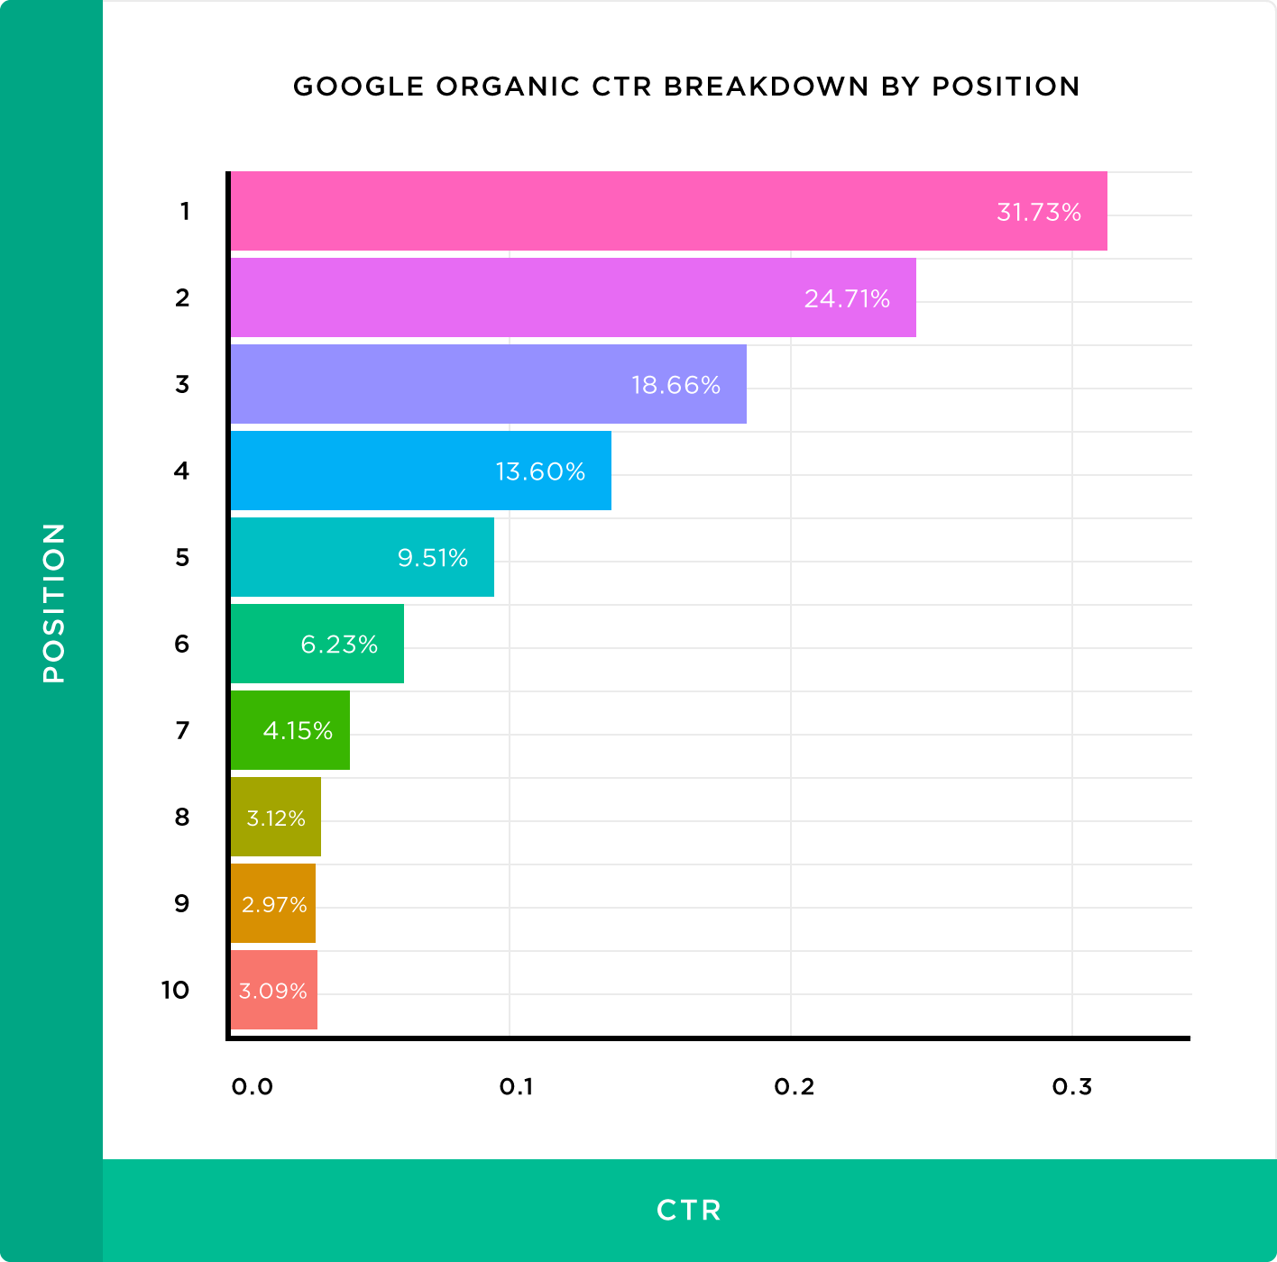

Analysing your site’s keyword traffic is essential to determine where your most valuable traffic is coming from, while performing keyword research highlights potential opportunities you may have missed.

By doing this you can refine your SEO efforts, optimise your pages and capture additional traffic from relevant searches.

If you want to estimate the SEO value of ranking at a particular position in the top 10, there is a useful formula:

SEO Value = ((OSV*CTR)*CR)*PV

Where:
OSV = organic search volume
CTR = Click Through Rate (as per the graph above depending on ranking position)
CR = Conversion Rate (average is 3% of visitors to your website)
PV = Product Value

FINDINGS

- The keyword online casino bahamas has a monthly search volume of 80. This is a relevant non-branded keyword for Paradise Games, but it is also a competitive gambling term.
  - Moving into position 10 would generate roughly 3 visits per month.
  - Moving into position 6 would increase traffic to roughly 5 visits per month.
  - Moving into position 3 would increase traffic to roughly 14 visits per month.
  - Moving into position 1 would increase traffic to roughly 26 visits per month.
- N/A
- N/A

RECOMMENDATIONS
- This example shows the importance of not just being in the top 10 positions, but specifically in the top 3 positions.

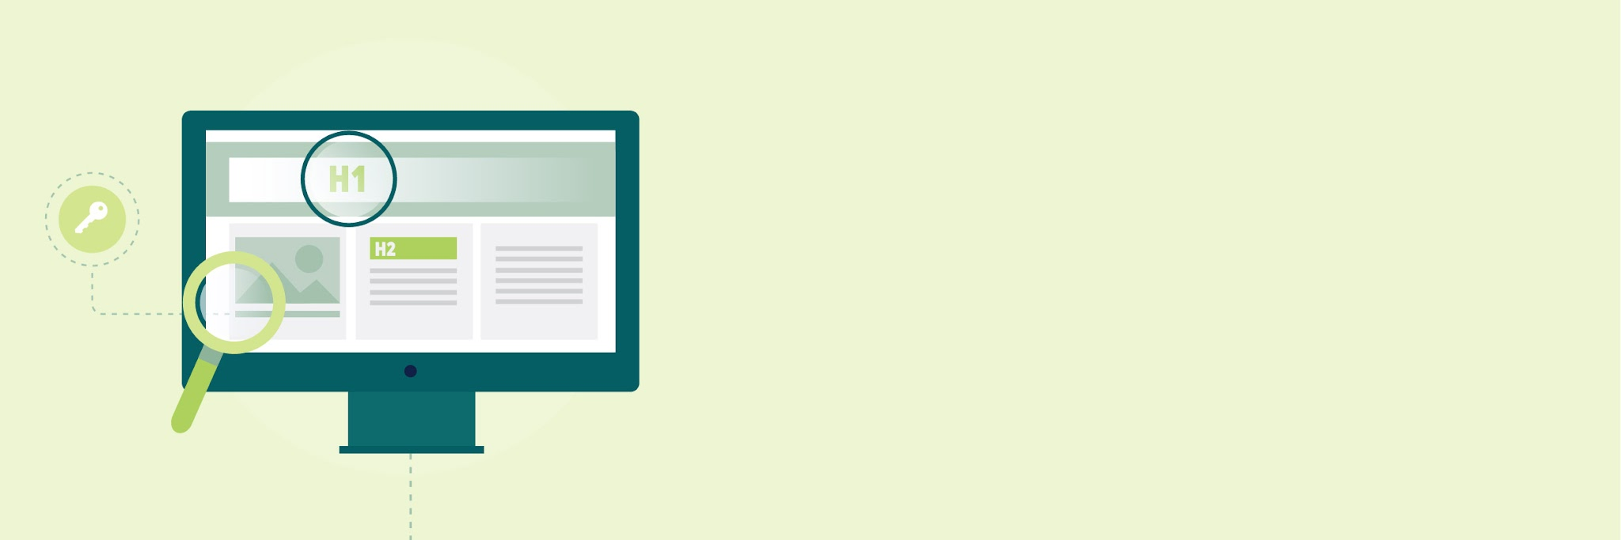
lON PAGE SEOl

On Page SEO
In this section we look at various On Page aspects of your website which can impact SEO and user experience. We will incorporate site-wide data, where applicable.

We will focus on the following example pages for illustration:
- Home page: https://pggames.com/
- Results page: https://classic.pggames.com/Mobile/Results
- Mobile entry page findings: https://classic.pggames.com/Mobile/

Page Titles

A title tag is an HTML element that specifies the title of a web page. Title tags are displayed on search engine results pages (SERPs) as the clickable headline for a given result, and are important for usability, SEO, and social sharing.
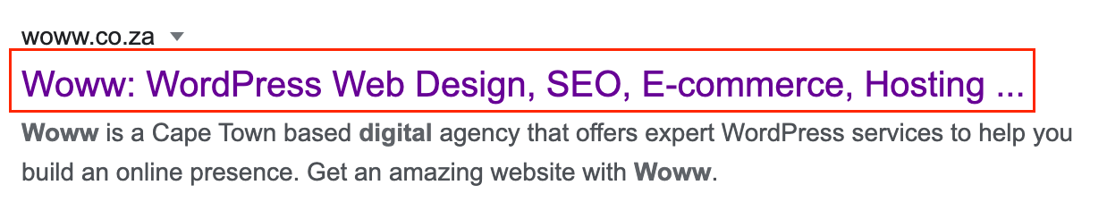

The title tag of a web page is meant to be an accurate and concise description of a page's content. You can utilize your meta description to add more creative call to actions whereas your Titles should be succinct and include the direct keywords and terms.

Moz published a useful guide on how to write a good title tag. It looks at what you should do and what to avoid.

DATA COLLECTION

 | Short titles
 | Long titles
 | Duplicate titles
 | Title suffixes

GENERAL FINDINGS

- 0 pages have titles that are too long.
- 11 indexable pages have duplicate titles.
  - This affects every indexable page in the titles workbook.
  - The duplicate title groups are mainly caused by:
    - pggames.com and www.pggames.com versions both being indexable.
    - Several classic mobile pages using the same generic Paradise Games title.
    - Footer pages using the same low-value title.
- 6 pages are not using the page title in the SERP.
  - This suggests Google may be rewriting titles because they are too short, too generic, duplicated, or not descriptive enough.
- Key SEO landing pages have weak title targeting.
  - The homepage title Home - Paradise Games is too generic.
  - The results page title Paradise Games does not describe winning numbers, lottery results, or lotto results.
  - The classic mobile pages do not have differentiated titles.
- N/A

GENERAL RECOMMENDATIONS
- Rewrite short and generic titles so each important indexable page clearly describes its purpose.
  - Focus first on the homepage, results page, and any page intended to support casino, account access, or user conversion.
- Resolve duplicate titles between pggames.com and www.pggames.com.
  - Clarify the preferred canonical version of each page.
  - Make sure internal links, canonicals, redirects, and sitemap references consistently support the preferred version.
- Give the results page a descriptive keyword-led title.
  - For example: Winning Numbers & Lottery Results | Paradise Games
  - This would better support searches around winning numbers, lottery results, lotto results, today’s results, and previous results.
- Improve the homepage title so it is more descriptive than Home - Paradise Games.
  - For example: Paradise Games | Lotto, Casino & Sports Betting in The Bahamas
- Give each classic mobile page a unique title if it remains indexable.
  - Paradise Games Results
  - Paradise Games Sign Up
  - Paradise Games Account Recovery
  - Paradise Games Terms & Promotions
- Review whether footer and utility pages should remain indexable.
  - If they are not useful search landing pages, consider noindexing them.
  - If they remain indexable, rewrite their titles so they describe the page purpose clearly.

HOME PAGE FINDINGS: https://pggames.com/
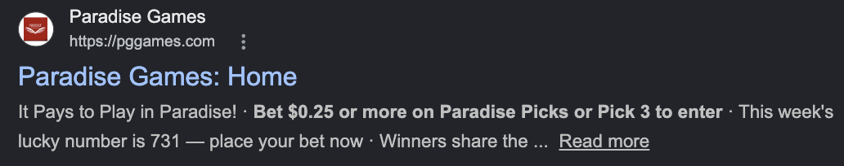

- N/A
- The meta title set is Home - Paradise Games.
  - This title is too short and generic.
  - It does not describe the full Paradise Games offering, such as lotto, casino, sportsbook, results, or Bahamas locations.
- Google has changed the title from Home - Paradise Games to Paradise Games: Home.
  - This suggests Google does not see the current title as descriptive enough.
  - The title is also duplicated with https://www.pggames.com/.
- N/A

RECOMMENDATIONS
- Rewrite the homepage title so it better describes the brand and offering.
  - Suggested title: Paradise Games | Lotto, Casino & Sports Betting in The Bahamas
  - This is more useful than Home - Paradise Games because it includes the main services users may be searching for.
  - Also review whether https://pggames.com/ or https://www.pggames.com/ should be the preferred canonical homepage.

RESULTS PAGE FINDINGS: https://classic.pggames.com/Mobile/Results
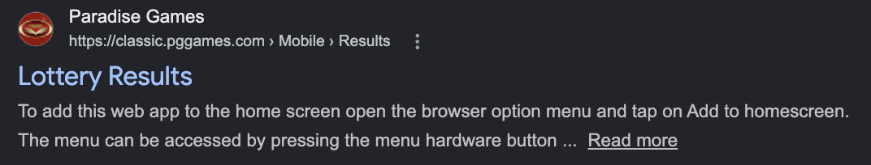

- Google is showing the page as Lottery Results, which is more descriptive than the current title.
- The meta title set is Paradise Games.
  - This is too short and generic.
  - It does not describe the page purpose.
  - The same title is used across 5 classic mobile pages, creating duplicate title issues.
- Google has changed the title from Paradise Games to Lottery Results.
  - This suggests Google understands the page topic but is rewriting the title because the set title is too vague.
- n/a

RECOMMENDATIONS
- Rewrite the results page title so it clearly targets result-led searches.
  - Suggested title: Lottery Results & Winning Numbers | Paradise Games
  - This better matches the page purpose and relevant keywords such as lottery results, winning numbers, lotto results, and previous results.
  - If this is not the preferred SEO results page, create or optimise a main-site results page and canonicalise/redirect the classic mobile version where appropriate.

MOBILE ENTRY PAGE FINDINGS: https://classic.pggames.com/Mobile/
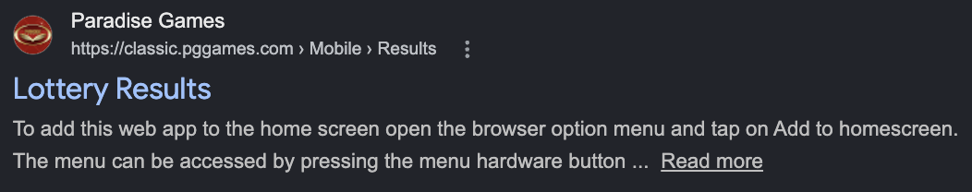

- Google is displaying the page as Lottery Results.
  - This is more descriptive than the title currently set on the page.
  - It better matches the likely search intent around lottery results and winning numbers.
- The meta title set is Paradise Games.
  - This title is too short and generic.
  - It does not describe the page purpose.
  - The same title is used across 5 classic mobile pages, creating duplicate title issues.
- Google has changed the title from Paradise Games to Lottery Results.
  - This suggests Google understands the page topic but is rewriting the title because the set title is not descriptive enough.
- N/A

RECOMMENDATIONS
- Rewrite the results page title so it clearly describes the page.
  - Suggested title: Lottery Results & Winning Numbers | Paradise Games
  - This better supports searches around lottery results, winning numbers, lotto results, today’s results, and previous results.
- Review whether this is the preferred SEO results page.
  - If it is, optimise it as the main landing page for result-led searches.
  - If a different results page should rank, canonicalise or redirect this page appropriately.

Meta Descriptions

The meta description is a snippet of up to about 155 characters – a tag in HTML – which summarizes a page’s content. Search engines show the meta description in the search results.

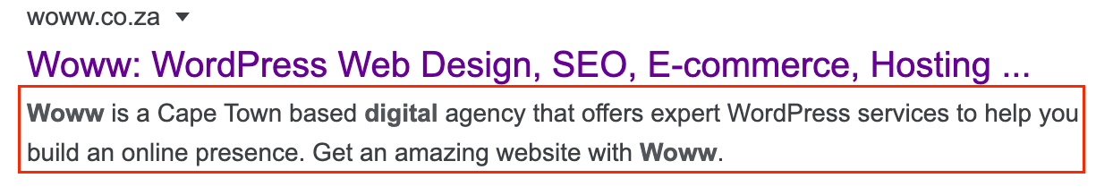

Generally, the searched-for phrase shows up within the meta description, so optimizing the meta description is crucial for on-page SEO.

Studies have lately shown that metas don’t affect SEO as much as they do user click through rates. Optimization of your metas descriptions will provide the user with a better chance of clicking if it matches their intent.

Meta descriptions are not a big ranking factor any longer, but you can try to use this section as an opportunity to convert users or give them a snippet of the information they may be looking for (pricing, list of items required, or location) - this encourages users to click through and read more.

Click Through Rate is however a ranking factor, so maximising CTR through meta descriptions makes meta descriptions a ranking factor by proxy.

DATA COLLECTION

 | Missing metas
 | Long metas
 | Short metas
 | Duplicate metas

GENERAL FINDINGS

- 0 pages have short meta descriptions.
- 0 pages have duplicate meta descriptions.
- 1 page has a long meta description.
  - https://classic.pggames.com/Mobile/
  - The meta description is 160 characters, which is slightly longer than the recommended range (max 140 characters).
- 10 pages are missing meta descriptions.
  - This affects 10 out of 11 indexable pages in the meta descriptions workbook.
  - Missing meta descriptions include important pages such as:
    - https://pggames.com/
    - https://www.pggames.com/
    - https://classic.pggames.com/Mobile/Results
    - https://classic.pggames.com/Mobile/SignUp
    - https://classic.pggames.com/Mobile/RecoverPin
  - This means most indexable pages do not have a controlled SERP description.
- Key SEO landing pages are missing meta descriptions.
  - The homepage is missing a meta description.
  - The results page is missing a meta description.
  - Several mobile/utility pages are missing meta descriptions.

GENERAL RECOMMENDATIONS
- Write meta descriptions for important indexable pages that are missing them.
  - Prioritise the homepage and results page first.
  - Then review sign-up, account recovery, terms, contact support, and footer/utility pages based on whether they should remain indexable.
- Keep meta descriptions between roughly 100 and 140 characters where possible.
  - Each description should summarise each page clearly.
  - It should include a reason to click.
  - It should include a natural call to action where appropriate.
- Write a homepage meta description that clearly explains the core offering.
  - Example: Play lotto, casino games and sportsbook with Paradise Games in The Bahamas. Sign up online to play now
- Write a results page meta description that supports winning numbers and lotto results intent.
  - Example: Check Paradise Games winning numbers, lotto results and previous draws online. View the latest results quickly and easily.
- Shorten the long meta description on https://classic.pggames.com/Mobile/.
  - Current length: 160 characters.
  - Reduce it to around 100-140 characters while keeping the core message clear.
- Review whether utility pages should remain indexable.
  - If pages such as account recovery, footer, and some mobile utility pages are not intended to rank, consider noindexing them.
  - If they remain indexable, give each one a clear, unique meta description.

HOME PAGE FINDINGS: https://pggames.com/


- N/A
- The homepage is missing a meta description.
  - This means Google is generating its own SERP description from on-page content.
  - The current SERP snippet is pulled from promotional page text rather than a controlled summary of the business.
- N/A

RECOMMENDATIONS
- Add a unique homepage meta description.
  - Suggested description: Play lotto, casino games and sportsbook with Paradise Games in The Bahamas. Check results, sign up online or visit a local branch.
  - This gives users a clearer summary of the brand and offering.
  - It also gives Google a stronger candidate to use in the SERP.

RESULTS PAGE FINDINGS: https://classic.pggames.com/Mobile/Results


- N/A
- The results page is missing a meta description.
  - Google is generating the SERP description from unrelated page text.
  - The current snippet explains how to add the web app to the home screen, rather than describing lottery results or winning numbers.
- This may reduce click-through rate from users searching for lottery results.
  - The snippet does not clearly tell users that they can check results or winning numbers on this page.
- N/A

RECOMMENDATIONS
- Add a unique meta description for the results page.
  - Suggested description: Check the latest Paradise Games lottery results and winning numbers online. View recent results quickly and easily.
  - This better matches the page purpose and user intent.
- Make sure the description is supported by visible on-page copy.
  - Add short introductory copy explaining that users can check latest and previous results.
  - This will give Google stronger relevant text to use if it rewrites the snippet.

MOBILE ENTRY PAGE FINDINGS: https://classic.pggames.com/Mobile/


- The mobile entry page has a meta description.
  - It describes Paradise Games as offering lottery, casino, and sportsbook betting in The Bahamas.
- The meta description is slightly too long.
  - It is 160 characters.
  - It should ideally be shortened to roughly 100-140 characters.
- N/A

RECOMMENDATIONS
- Shorten the mobile entry page meta description.
  - Current description: Paradise Games specializes in lottery, casino, and sportsbook betting in The Bahamas. Visit Paradise Games online or at one of our 30+ locations to get started!
  - Suggested description: Play lotto, casino games and sportsbook with Paradise Games in The Bahamas. Sign up online or visit one of our 30+ locations.
- Review whether this page should remain indexable.
  - If it is intended to rank, keep the description unique and aligned with the page’s mobile access purpose.
  - If it is only a utility/mobile access page, consider whether it should be noindexed.

OG Tags & Twitter Cards

The open graph (OG) protocol allows developers to leverage Facebook in new and exciting ways. One of the easiest ways to venture into the world of Open Graph is to add the open graph meta tags to your site.

Open graph meta tags allow you to control what content shows up when a page is shared on Facebook. Twitter offers a similar function with Twitter Open Card Tags.

The most important OG tag attributes and Twitter Card attributes to have are: title, image, and description (as these are the attributes that the user will notice when scrolling).

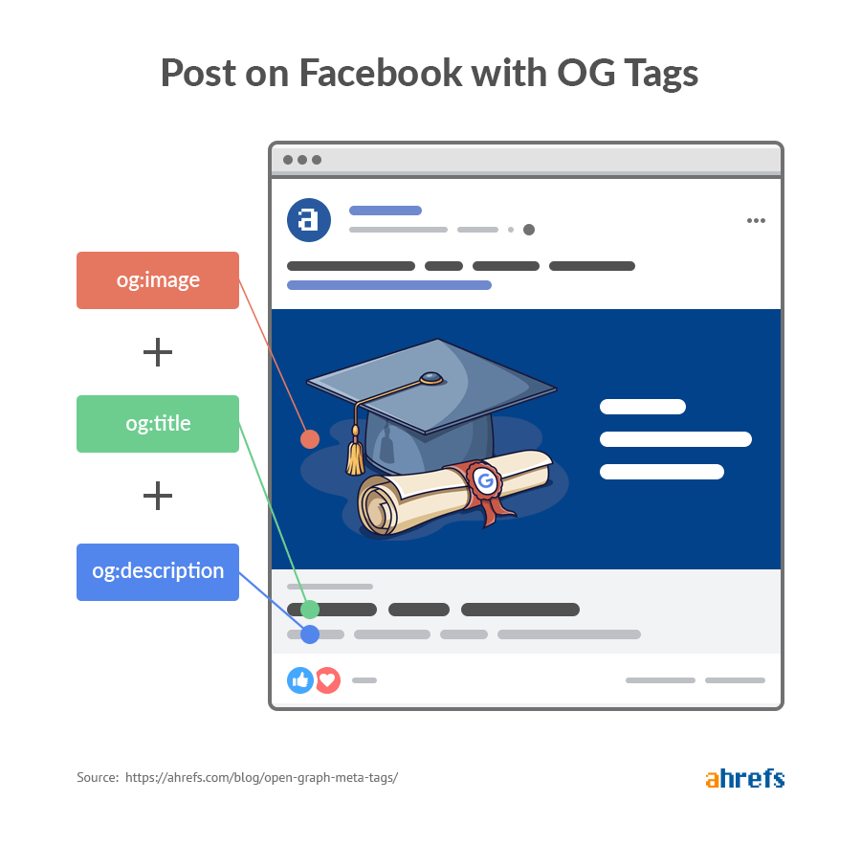

FINDINGS: OG Tags

- N/A
- N/A
- OG tags are missing for 11 indexable URLs.
  - This affects every URL in the workbook.
  - Important pages missing OG tags include:
    - https://pggames.com/
    - https://www.pggames.com/
    - https://classic.pggames.com/Mobile/Results
    - https://classic.pggames.com/Mobile/SignUp
    - https://classic.pggames.com/Mobile/
- Missing OG tags mean these pages may not display controlled titles, descriptions, images, or URLs when shared on social platforms.
  - This can reduce the quality of shared previews.
  - It can also make important pages look less polished when shared on Facebook, LinkedIn, WhatsApp, or other platforms that use Open Graph data.

FINDINGS: Twitter Cards

- N/A
- N/A
- Twitter Cards are missing for 11 indexable URLs.
  - This affects every URL in the workbook.
  - Important pages missing Twitter Cards include:
    - https://pggames.com/
    - https://www.pggames.com/
    - https://classic.pggames.com/Mobile/Results
    - https://classic.pggames.com/Mobile/SignUp
    - https://classic.pggames.com/Mobile/
- Missing Twitter Cards mean these pages may not render controlled previews when shared on X/Twitter.
  - Titles, descriptions, and images may be pulled inconsistently.
  - This may reduce click-through from social sharing.

RECOMMENDATIONS
- Add OG tags and Twitter Cards to all important indexable pages.
  - Prioritise the homepage, results page, mobile entry page, sign-up page, and any other page that should remain indexable.
  - Utility pages should only be optimised if they are intended to remain indexable and shareable.
- Add the following OG tags to the <head> section of each important page:
  - <meta property="og:title" content="Page Title">
  - <meta property="og:description" content="Page description">
  - <meta property="og:image" content="https://example.com/image.jpg">
  - <meta property="og:url" content="https://example.com/page-url">
  - <meta property="og:type" content="website">
- Add the following Twitter Card tags to the <head> section of each important page:
  - <meta name="twitter:card" content="summary_large_image">
  - <meta name="twitter:title" content="Page Title">
  - <meta name="twitter:description" content="Page description">
  - <meta name="twitter:image" content="https://example.com/image.jpg">
  - <meta name="twitter:url" content="https://example.com/page-url">
- Use unique social metadata for each key page.
  - The homepage should describe Paradise Games’ core offering.
  - The results page should reference winning numbers, lottery results, and recent results.
  - The mobile entry page should explain mobile access to Paradise Games.
  - Sign-up and account pages should only receive social metadata if they are intended to remain indexable and shareable.
- Use a consistent branded preview image.
  - The homepage should use a high-quality Paradise Games brand image.
  - Results pages should use an image that clearly relates to lottery results or winning numbers.
  - Avoid generic or missing preview images, as these can make shared links look unfinished.
- Review whether utility pages should remain indexable.
  - Pages such as account recovery, footer pages, and some classic mobile pages may not need OG tags or Twitter Cards if they are not intended to appear in search or be shared.
  - If these pages remain indexable, they should still have complete OG and Twitter Card tags.

H-Tag Heading Structure
Assistive technologies such as screen readers use heading tags (h1-h6) to give visitors an overview of a page without the need for them to read through the entire content.

Search engines can read headings to determine the importance of page sections. They can then use this information to gauge the page's 'weight' for the search engine listings.

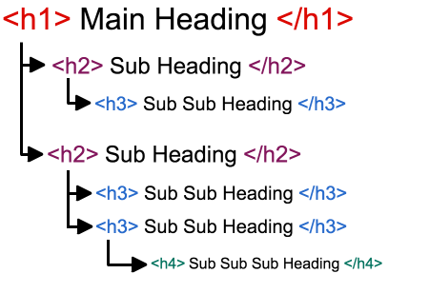
You can view headings and test this using this tool: http://www.seowebpageanalyzer.com/

DATA COLLECTION

 | Pages with multiple h1s
 | Pages missing h1s

GENERAL FINDINGS

- N/A
- 5 indexable pages have multiple H1s.
  - https://pggames.com/ has 2 H1s.
  - https://www.pggames.com/ has 2 H1s.
  - https://www.pggames.com/home/contactsupport has 2 H1s.
  - https://pggames.com/home/contactsupport has 2 H1s.
  - https://classic.pggames.com/Mobile/Terms has 7 H1s.
- Some H1s are not aligned with the page’s SEO purpose.
  - The homepage includes SMS Verification as an H1.
  - The sign-up page uses SMS Verification as its only H1.
  - Contact support pages include SMS Verification as an H1 alongside a support confirmation message.
- The terms/promotions page uses several promotion names as H1s.
  - This creates a flat heading structure.
  - These promotion names would be better handled as H2s or H3s under one clear H1.
- 5 indexable pages are missing H1s.
  - https://classic.pggames.com/Mobile/Results
  - https://classic.pggames.com/Mobile/RecoverPin
  - https://pggames.com/footer
  - https://www.pggames.com/footer
  - https://classic.pggames.com/Mobile/
- Important pages are missing clear heading signals.
  - The results page has no H1, despite being one of the most important pages for lottery results and winning numbers intent.
  - The mobile entry page has no H1, despite being indexable.
- Some important page content is being communicated visually through banners, sliders, and game grids rather than through crawlable headings and supporting text.
  - On the homepage, key promotions and game sections are visible to users, but the page does not give search engines a strong text-based structure for understanding these sections.
  - Promotional banners use text baked into images, which means key messages such as offers, tournament names, casino promotions, and sports betting campaigns may not be fully crawlable.
  - Casino/game tiles are also largely image-led and link users to a sign-up pop-up, but they do not consistently include crawlable headings or short descriptions that explain the game or category.

GENERAL RECOMMENDATIONS
- Use crawlable headings and supporting copy to describe key homepage sections, banners, promotions, and game grids.
  - Promotional sliders should be supported by visible H2/H3 headings and short text descriptions, rather than relying only on image-based creative.
  - Game grids should include crawlable game/category names and short descriptions where possible, especially for slots, table games, casino, lottery, sportsbook, featured games, and promotions.
  - This will help search engines better understand the homepage structure while also improving accessibility and user clarity.
- Ensure each important indexable page has one clear, descriptive H1.
  - The H1 should describe the main purpose of the page.
  - It should align naturally with the page title and target keyword theme.
- Add a clear H1 to the results page.
  - Suggested H1: Lottery Results & Winning Numbers
  - This would better support searches around lottery results, winning numbers, lotto results, today’s results, and previous results.
- Improve the homepage H1 structure.
  - Remove SMS Verification as an H1.
  - Use one main H1 that describes the brand and offering, such as Lotto, Casino & Sportsbook Betting in The Bahamas.
- Review utility pages before optimising their H1s.
  - Pages such as account recovery, footer pages, and some mobile utility pages may not need to be indexable.
  - If they remain indexable, each should have one clear H1 that describes its purpose.
- Restructure the terms/promotions page.
  - Use one main H1 for the overall page topic.
  - Move individual promotion names into H2s or H3s.
  - This will create a clearer hierarchy for users and search engines.
- Avoid using functional interface text as H1s.
  - SMS Verification should not be the main H1 on pages where the primary purpose is homepage, sign-up, or support content.

HOME PAGE FINDINGS: https://pggames.com/
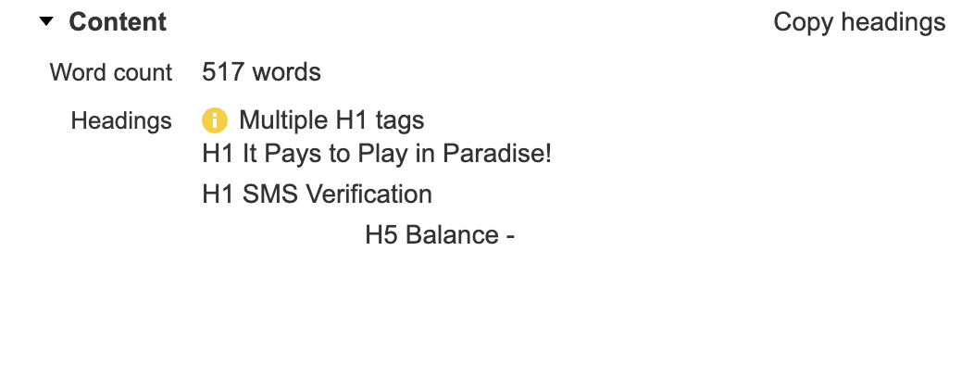
- N/A
- Key homepage offerings and promotions are often communicated through image banners and game tiles rather than crawlable text.
  - This includes the hero/promotional banners and the casino game sections. I.e these are just images, text is not crawlable.

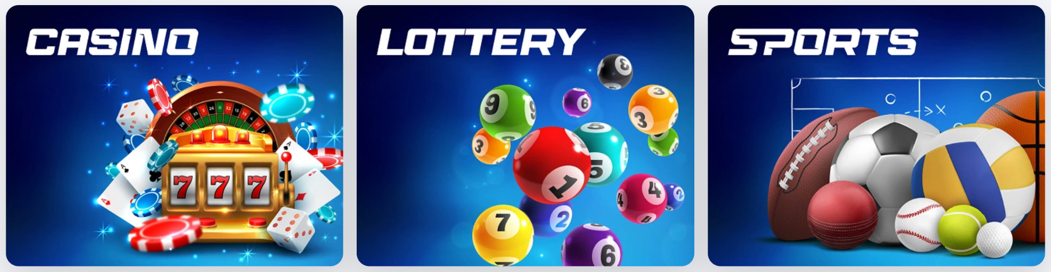
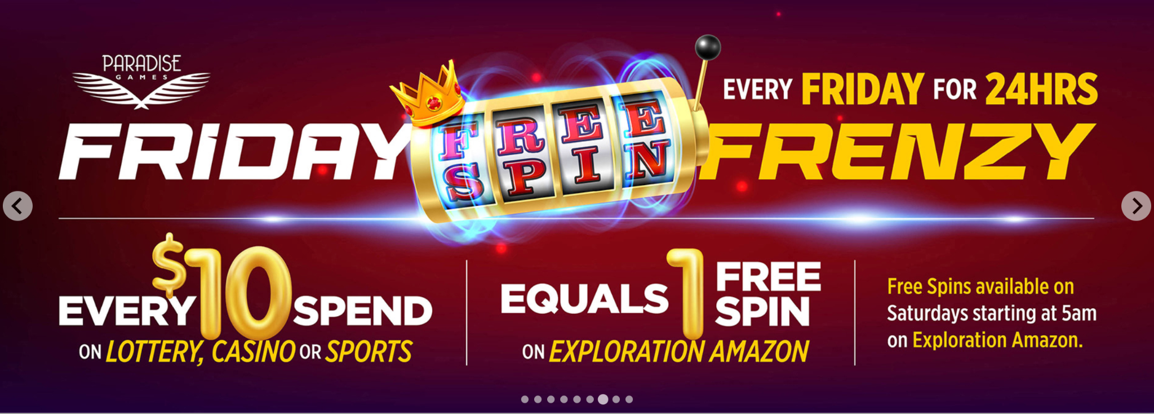

  - Search engines may not fully understand this content if key headings, game names, descriptions, and promotional details are baked into images.
  - The games shown on the homepage also need short crawlable descriptions and clearer headings, rather than relying only on image tiles that link to a sign-up pop-up.
- The homepage has multiple H1 tags.
  - H1: It Pays to Play in Paradise!
  - H1: SMS Verification
  - This weakens the heading structure because there is not one clear primary heading for the page.
- The homepage H1 does not fully describe the core offering.
  - It Pays to Play in Paradise! works as a brand message, but it does not clearly communicate lotto, casino, sportsbook, results, or Bahamas betting intent.
  - SMS Verification should not be marked up as an H1.
- The heading hierarchy is very shallow.
  - The page moves from H1s to an H5 (Balance -) without a clear H2/H3 structure.
  - This makes the page harder for search engines and users to understand structurally.

RECOMMENDATIONS
- Use one clear H1 on the homepage.
  - Suggested H1: Lotto, Casino & Sportsbook Betting in The Bahamas
  - Keep It Pays to Play in Paradise! as supporting copy or a visual tagline rather than the only SEO-focused H1.
  - Change SMS Verification to normal interface text or a lower-level heading if needed.
- Add a clearer supporting heading structure.
  - Use H2s for major sections such as Lottery Results, Casino Games, Sportsbook, Promotions, Locations, and Account Access.
  - Use H3s for sub-sections within those areas.
  - Avoid jumping from H1 to H5 unless the page structure genuinely requires it.
- Use crawlable text headings and short descriptions alongside homepage banners and game tiles.
  - Promotions, casino games, slots, table games, sportsbook, lottery, and featured games should be supported by visible text on the page, not only image-based creative.
    - Example heading structure:
    - H1: Paradise Games: Lotto, Casino & Sports Betting in The Bahamas
      - H2: Weekend Winnings Slot Tournament
      - H2: 2X Casino Rewards
      - H2: Play Number of the Week
      - H2: Spintastic Tuesdays
      - H2: Bet on the NBA Playoffs
        - ^These h2s are sliders/banners in the hero.
        - Use text on the website as opposed to images to communicate key offerings.
      - H2: Table Games
        - H3: Roulette
        - H3: Blackjack
        - Etc
      - H2: Slots
        - H3: Slot game 1
        - H3: Slot game 2
        - H3: Slot game 3
      - H2: Top Games
      - H2: Favourite Games
      - H2: New Games
        - H3: Bahamas Happy Hour
        - H3: Carnival Rio
        - H3: Jack & the Beanstalk
        - Etc
      - H2: Casino
      - H2: Lottery
      - H2: Sports Betting
        - H3: Premier League
        - H3: NBA
        - H3: NFL
        - Etc
      - H2: Promotions
      - H2: Featured
      - H2: Sign up to play now

RESULTS PAGE FINDINGS: https://classic.pggames.com/Mobile/Results
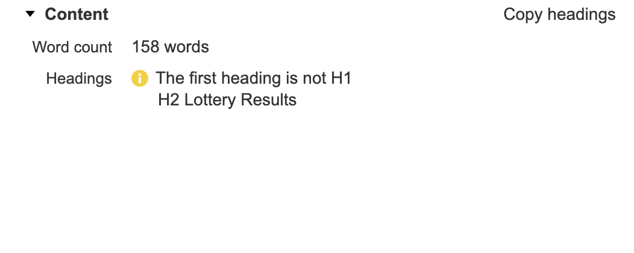
- The results page does not have an H1.
  - The first heading is an H2: Lottery Results.
  - This is an important page for results and winning-number searches, so it should have a clear H1.

- The heading structure is incomplete.
  - The page begins with an H2 rather than an H1.
  - There is no broader heading hierarchy to support related sections such as today’s results, previous results, or game-specific results.
- The page has limited supporting content.
  - For a results-focused page, this may not provide enough context around winning numbers, lottery results, today’s results, previous results, or how users should check results.
- n/a

RECOMMENDATIONS
- Change “Lottery Results” from an H2 to an H1.
  - Suggested H1: Lottery Results & Winning Numbers
  - This better aligns with keyword opportunities around lottery results, lotto results, winning numbers, and today’s results.
- Add a clearer heading hierarchy below the H1.
  - Use H2s for sections such as Today’s Results, Previous Results, and How to Check Winning Numbers.
  - Use H3s for individual games or result categories where relevant.
- Add concise supporting copy below the H1.
  - Explain that users can check the latest Paradise Games results and winning numbers.
  - Include links or sections for today’s results, previous results, and game-specific results where available.

MOBILE ENTRY PAGE FINDINGS: https://classic.pggames.com/Mobile/
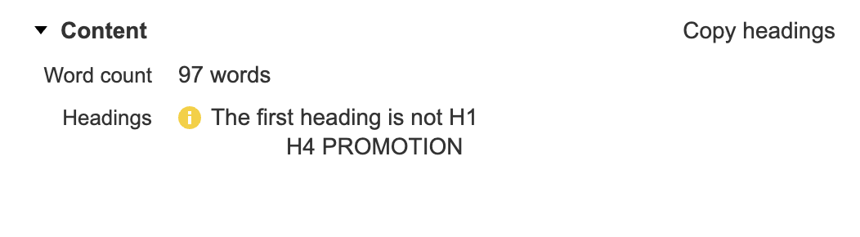
- The mobile entry page does not have an H1.
  - The first heading is an H4: PROMOTION.
  - This is a poor heading structure because the page skips H1, H2, and H3.
- The heading hierarchy is not logical.
  - Starting with an H4 makes the page appear structurally incomplete.
  - The page does not clearly identify its main topic before introducing a promotion section.
- The page has thin content.
  - The screenshot shows 97 words.
  - If this page remains indexable, it does not provide enough context about the page purpose or Paradise Games’ offering.
- n/a

RECOMMENDATIONS
- Add one clear H1 if the page should remain indexable.
  - Suggested H1: Paradise Games Mobile
  - Alternative: Play Paradise Games on Mobile
- Restructure the heading hierarchy.
  - Use H1 for the main page topic.
  - Use H2s for major sections such as Promotions, Login, Sign Up, Results, Casino, and Sportsbook.
  - Use H3s for supporting details within those sections.
  - Do not use H4 as the first visible heading.
- Review whether this page should remain indexable.
  - If it is only a utility/mobile access page, consider noindexing it.
  - If it is intended to rank, add clearer introductory copy and internal links to results, sign-up, casino, and sportsbook pages.

Media, Images and Alt Text
The images you use say a lot about your content. Unfortunately, Google is really bad at understanding what images are.

To help with this problem you want to use Alt Text, which are tags that describe the appearance and function of images on your page.

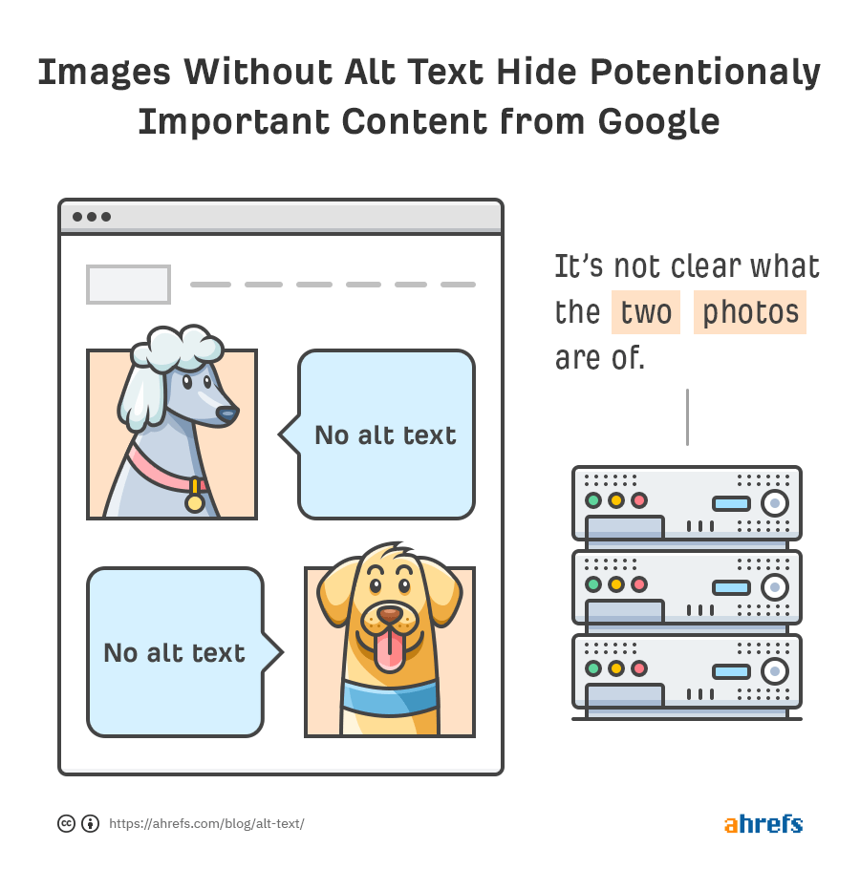

Optimal Alt text is descriptive but doesn’t contain spammy keywords.

Here’s an example to better understand how you should write alt text tags for your images.
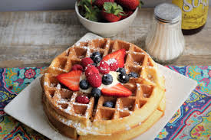
<img src="waffle.png"

Okay: “waffle”
Good: “stack of waffles with strawberries and powdered sugar”
Not recommended:
Blank " " or “waffle waffles breakfast food best breakfast top breakfasts breakfast recipes waffle recipe"

For more information on alt tags, Moz has written helpful guidelines on what to do and what to avoid.

DATA COLLECTION

 | Unique images
 | Unique alt text

GENERAL FINDINGS

- 70 image instances have alt text.
  - Some important recurring assets, such as the site logo and main category images, already have alt attributes.
  - Examples of existing alt text include Site Logo, Login, Sign Up, Popular, Promo, Sports, Casino, and Lotto.
- Some existing alt text is too generic.
  - 32 image instances use the alt text Featured Image.
  - This does not describe the specific image, game, promotion, or page context.
  - Generic alt text is less useful for accessibility and does not help reinforce page relevance.
- Several important visual assets are missing descriptive alt text.
  - Missing alt text appears on slideshow banners, promotional images, casino/sportsbook/lottery icons, and mobile page images.
  - These images appear across key pages such as:
    - https://pggames.com/
    - https://www.pggames.com/
    - https://classic.pggames.com/Mobile/Results
    - https://classic.pggames.com/Mobile/
    - https://classic.pggames.com/Mobile/Terms
- 103 image instances are missing alt text.
  - This affects 43 unique images.
  - Missing alt text is a site-wide issue across the pages reviewed.
- 1 image returns a 404 status code.
  - Broken image: https://classic.pggames.com/Images/Modal/promo-image.jpg
  - Found on: https://classic.pggames.com/Mobile/
  - Broken images can harm user experience and make the page look poorly maintained.

GENERAL RECOMMENDATIONS
- Add descriptive alt text to important images that are missing it.
  - Prioritise images on the homepage, results page, mobile entry page, sign-up page, and terms/promotions page.
  - Focus first on images that communicate useful information, promotions, game categories, or navigation options.
- Rewrite generic alt text such as Featured Image.
  - Alt text should describe what the image shows or what it represents.
  - For example, use descriptions such as Paradise Games casino promotion, Paradise Games sportsbook banner, Paradise Games lottery results promotion, or Paradise Games slot tournament banner where accurate.
- Do not force keywords into every image alt attribute.
  - Alt text should be useful and natural.
  - Decorative icons or purely visual elements can use empty alt text where appropriate.
  - Informative images should have clear, descriptive alt text.
- Fix the broken image on the mobile entry page.
  - Replace or remove https://classic.pggames.com/Images/Modal/promo-image.jpg.
  - If the image is still needed, update the image source so it returns a 200 status code.
- Use consistent alt text conventions across repeated assets.
  - Logos should use consistent branding, such as Paradise Games logo.
  - Navigation icons should describe the destination or function, such as Casino games, Sportsbook, or Lottery.
  - Promotional banners should describe the specific promotion where possible.
- Review image filenames where practical.
  - Some image filenames are generic or asset-code based.
  - When new images are uploaded, use descriptive filenames that reflect the image topic, promotion, game, or page context.

HOME PAGE FINDINGS: https://pggames.com/Images/SlideShow/Banner-000.jpg
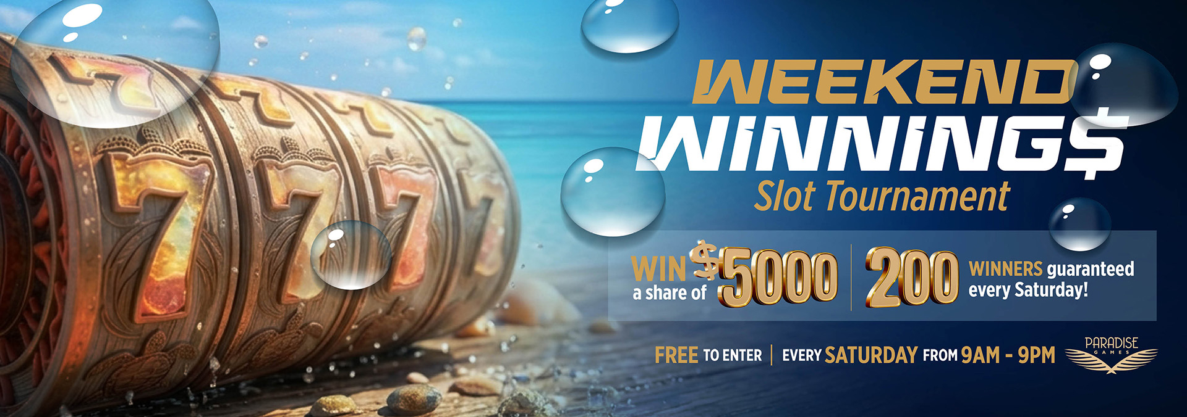

- Image URL is https://pggames.com/Images/SlideShow/Banner-000.jpg
- Image filename is banner-000.jpg
- Alt text is missing
- File size is 872kb

RECOMMENDATIONS
- Add descriptive alt text to the image.
  - Suggested alt text: Weekend Winnings slot tournament promotion
  - Alternative: Paradise Games Weekend Winnings slot tournament banner
- Improve the image filename when the image is next updated or re-uploaded.
  - Current filename: Banner-000.jpg
  - Suggested filename: paradise-games-weekend-winnings-slot-tournament.jpg
- Reduce the image file size.
  - The file size is 872kb, which is relatively large for a web banner.
  - Compress the image before uploading while keeping it visually clear.
  - Aim to serve the image in a modern format such as WebP where possible.
- Keep promotional banner alt text concise and descriptive.
  - The alt text should explain the purpose of the image, not repeat every line of text in the graphic.
  - Avoid keyword stuffing or overly long alt text.

HOME PAGE FINDINGS: https://pggames.com/images/casino-img.webp
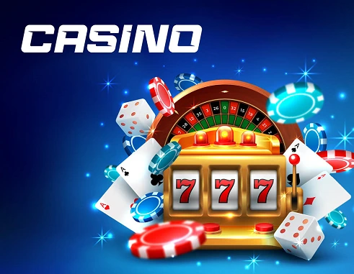

- Image URL is https://pggames.com/images/casino-img.webp
- File size is 42kb
- Image filename is casino-img.webp
- Alt text is casino
- N/A

RECOMMENDATIONS
- Improve the image filename when the image is next updated or re-uploaded.
  - Current filename: casino-img.webp
  - Suggested filename: paradise-games-online-casino.webp
  - This is more descriptive and better aligned with the image topic.
- Improve the alt text so it is more descriptive.
  - Current alt text: casino
  - Suggested alt text: Paradise Games online casino games
  - Alternative: Online casino games at Paradise Games

HOME PAGE FINDINGS: https://pggames.com/images/sports-img.webp


- File size is 34.4kb
- Image URL is https://pggames.com/images/sports-img.webp
- Image filename is sports-img.webp
- Alt text is sports
- N/A

RECOMMENDATIONS
- Improve the image filename when the image is next updated or re-uploaded.
  - Current filename: sports-img.webp
  - Suggested filename: paradise-games-sportsbook.webp
  - Alternative: paradise-games-sports-betting.webp
  - This is more descriptive and better aligned with the image topic.
- Improve the alt text so it is more specific.
  - Current alt text: sports
  - Suggested alt text: Paradise Games sportsbook and sports betting
  - Alternative: Sports betting at Paradise Games
- Avoid overly generic alt text for important category images.
  - sports is better than missing alt text, but it does not provide much context.
  - Use short, descriptive alt text that explains the image and supports the page topic naturally.

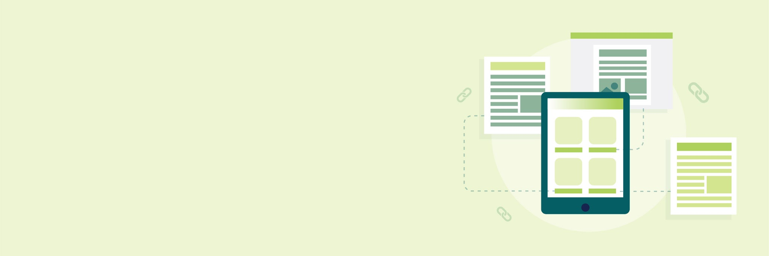
lLINKS & SILOINGl

Links & Siloing
In this section we will look at site structure both in terms of physical siloing as well as virtual siloing and anchor text. These attributes will be analysed in terms of how they improve Google’s understanding of your site and user experience.

Physical Siloing & URL Structure

Siloing is a form of site architecture where hierarchical groupings are created that are determined by topics and subtopics.

Physical siloing is when theme-related pages to be located within the same directory of a site, such as:
- In the URL https://www.example.com/blog/title “/blog/” is a physical silo. It allows users to understand that the URL is a blog post. It allows Google to understand the intent of the page better.
- Likewise, in https://www.example.com/services/seo “/services/” is a physical silo.
- In the case of https://www.example.com/services/seo/audit “/services/” and “/seo/” would be physical silos.

Besides physical siloing there are several other factors relating to URLs which can affect your position on Google:
- The URL being short (measured in number of characters)
- The presence of keywords in the URL
  - Typically you want your main keyword in the URL.
  - The keyword should appear in the first few words of the URL.
  - Avoid having too many keywords (as this will make the URL longer and Google doesn’t like “keyword stuffing”).

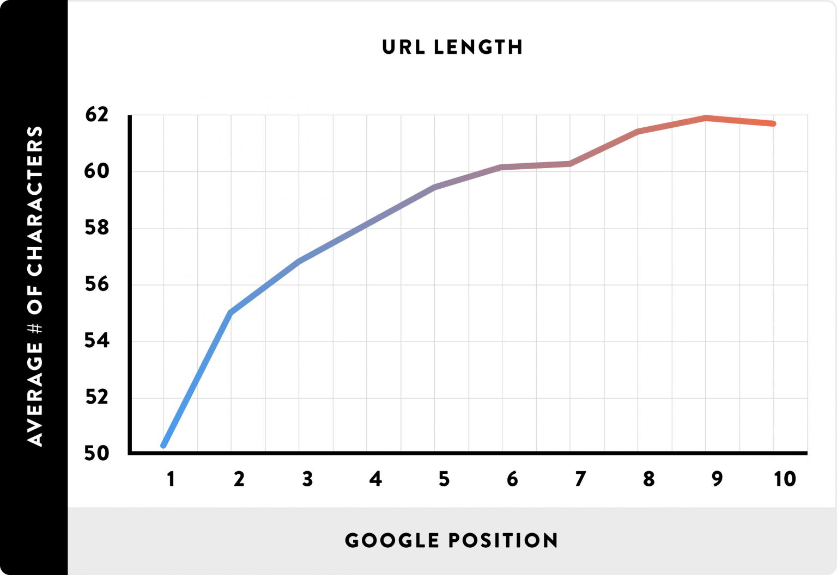

These additional factors should be taken into account when creating physical siloing, going back to our previous example:
- In the URL https://www.example.com/services/seo/seo-audit the second use of “seo” is unnecessary because:
  - “seo” already appears in the URL and this would count as keyword stuffing.
  - It makes the URL longer.
  - It moves the main keyword “seo audit” further away from the start of the URL.
- However, in the URL https://www.example.com/services/seo/content-audit the use of “content” adds value (from an SEO perspective).

DATA COLLECTION

 | Long URLs
 | Stop words

FINDINGS

- All URLs reviewed return a 200 status code and are indexable.
  - This means the pages included in the Paradise Games URL set are accessible to search engines.
  - There are no 404, 500, or redirecting URLs in this specific URL set.
- The site has both https://pggames.com/ and https://www.pggames.com/ versions indexable.
  - Both versions of the homepage return 200 and are indexable.
  - This can split signals between duplicate URL versions if canonicalisation and internal linking are not handled consistently.
- Several duplicate www and non-www page versions are indexable.
  - Examples include:
    - https://pggames.com/
    - https://www.pggames.com/
    - https://pggames.com/home/contactsupport
    - https://www.pggames.com/home/contactsupport
    - https://pggames.com/footer
    - https://www.pggames.com/footer
- Some indexable URLs are utility-style pages rather than strong SEO landing pages.
  - Examples include:
    - https://classic.pggames.com/Mobile/RecoverPin
    - https://pggames.com/footer
    - https://www.pggames.com/footer
  - These may be useful for users, but they are unlikely to be valuable organic landing pages.
- Several URLs are missing trailing slashes.
  - Examples include:
    - https://www.pggames.com/home/contactsupport
    - https://classic.pggames.com/Mobile/Results
    - https://classic.pggames.com/Mobile/SignUp
    - https://classic.pggames.com/Mobile/RecoverPin
    - https://classic.pggames.com/Mobile/Terms
  - This is not necessarily a problem if handled consistently, but inconsistent trailing slash behaviour can create duplicate URL issues.
- The site has a very small indexable URL set.
  - This makes the physical siloing fairly shallow.
  - There are not many dedicated indexable pages for important themes such as results, lotto products, casino, sportsbook, promotions, locations, or support content.
- N/A

GENERAL RECOMMENDATIONS
- Choose one preferred canonical homepage version.
  - Decide whether https://pggames.com/ or https://www.pggames.com/ should be the primary version.
  - Redirect the non-preferred version to the preferred version.
  - Ensure canonical tags, internal links, and sitemap URLs all use the preferred version.
- Resolve duplicate www and non-www URL versions.
  - Apply the same preferred-domain logic across contact, footer, and other page types.
  - This will help consolidate ranking signals and reduce duplicate URL issues.
- Review whether utility pages should remain indexable.
  - Pages such as account recovery and footer pages may not need to appear in search results.
  - If they are useful only for existing users, consider setting them to noindex.
  - If they remain indexable, improve their titles, meta descriptions, headings, and internal links so their purpose is clear.
- Clarify the preferred results URL.
  - If https://classic.pggames.com/Mobile/Results is the main results page, optimise it as the primary SEO landing page for lottery results and winning numbers.
  - If a cleaner main-site results page should rank instead, create or optimise that page and canonicalise or redirect the classic mobile version as appropriate.
- Use a consistent trailing slash strategy.
  - Either trailing slash or non-trailing slash URLs can work, but the site should handle them consistently.
  - Redirect alternate versions to the preferred format where needed.
- Build clearer page silos for priority keyword themes where suitable pages do not already exist.
  - Results / winning numbers
  - Lotto products
  - Casino games
  - Sportsbook
  - Promotions
  - Locations / branches
  - Support / account help
- Keep the structure lean.
  - Do not create thin pages for every keyword variation.
  - New pages should only be created where there is a clear user intent, search opportunity, and business reason.

PAGE URL: https://pggames.com/home/contactsupport

RECOMMENDATIONS
- Consider cleaning up the URL
  - /home/ shouldn’t be there, and may cause confusion to search engines
  - Choose either /contact or /support as the end path, or separate the terms properly as /contact-support
    - E.g. https://pggames.com/contact

Virtual Siloing & Linking

A large part of how Google ranks pages is their authority, and this usually boils down to how many links are pointing to that page. When a link points to a page it will usually pass on authority (sometimes referred to as ‘link juice’).

Internal links direct users from pages on your site to other pages on your site, e.g. from your homepage to your contact page. These links can help spread authority to the important pages on your website.

Internal links can be used to create virtual siloing. Virtual siloing occurs when pages about a certain topic link to one another and/or to a central page on the topic, for example:

- The blog post https://www.example.com/blog/seo-audits-find-problems and other similar SEO posts link to the service page https://www.example.com/services/seo/audit

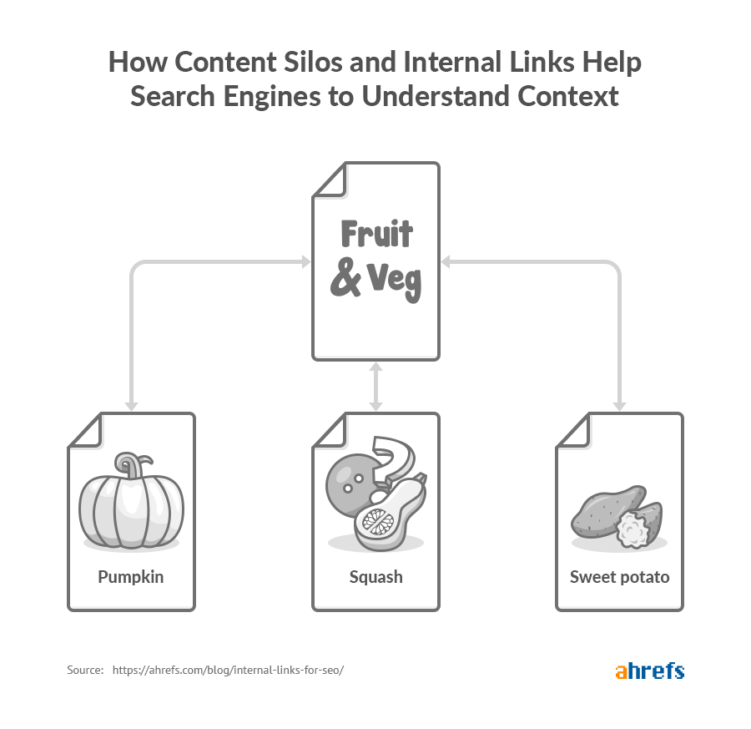

There are three main benefits of virtual siloing:

- Users will have an easier time navigating around your site.
- Crawlers will have an easier time understanding your site structure and content.
- More “authority” is transferred to your most important pages.

External links (aka outbound links) direct users from pages on your website to other sites on the internet, e.g. from your homepage to your Facebook profile. These links can pass authority from your site onto another site.

External links can provide relavency to search engines so that they better understand the intention of the page (e.g. if you have a page about apples and you link to the Wikipedia page about the fruit, then this will help Google to understand that you are not talking about the technology company).

External links are not to be confused with backlinks - backlinks are links from other sites to your site. Backlinks can pass authority on to your site.

Links can also have attributes such as:

- follow (which indicates to the search engine that authority should be passed on to the linked page)
- nofollow (which indicates that authority should not be passed on to the linked page)

You should use nofollow links when you are linking to pages you don’t have full confidence in or in your comments section (if you have one). In other cases just use follow links.

DATA COLLECTION

 | Internal linking
 | External linking
 | Orphan pages

FINDINGS

- All key indexable pages have at least some internal links pointing to them.
  - This means the main crawlable pages are not completely isolated.
  - The Results, Sign Up, Recover PIN, Terms, homepage, mobile entry, and contact pages are all discoverable through internal links.
- Internal linking is currently quite shallow.
  - Most priority pages only have a small number of internal links.
  - The homepage and mobile entry page have 3 internal links each.
  - The Results, Sign Up, Recover PIN, and Terms pages have 4 internal links each.
  - The contact pages only have 2 internal links each.
- Internal links appear to be heavily driven by navigation and utility links rather than contextual links.
  - This limits how clearly the site can signal the importance of pages such as Lottery Results, Sign Up, Casino, Sportsbook, and Mobile.
- Some non-priority/utility URLs receive more internal links than key SEO pages.
  - For example, footer URLs receive 14 internal links.
  - This suggests internal linking equity may not be focused on the most commercially or search-relevant pages.
- There are links pointing across different versions of the site, including pggames.com, www.pggames.com, and classic.pggames.com.
  - This can weaken clarity around the preferred destination for users and search engines.
  - This also links back to the URL structure/canonicalisation recommendations.
- Some internal links point to redirecting URLs.
  - These include links associated with mobile/desktop switching and classic/mobile URLs.
  - Redirecting internal links should be cleaned up where possible so links point directly to final 200-status pages.
- Some anchor text is generic.
  - Examples include Home, Desktop Site, Mobile Site, and (click here).
  - These do not give strong contextual signals about the destination page.
- There is a broken link on the Terms page.
  - Source URL: https://classic.pggames.com/Mobile/Terms
  - Broken target: https://classic.pggames.com/Mobile/~/Images/Gamingbill2014.pdf
  - Anchor text: (click here)
  - This should be fixed as it creates a poor user experience and weakens trust, especially for a gambling-related website.

RECOMMENDATIONS
- Strengthen internal linking to the most important pages.
  - Prioritise links to the homepage, Lottery Results page, Sign Up page, mobile entry page, Casino page, and Sportsbook page where these pages are intended to be indexable.
  - Use relevant anchors such as Lottery Results, Winning Numbers, Sign Up, Online Casino, Sportsbook, and Paradise Games Mobile.
- Add more contextual internal links within page content, not only in navigation.
  - The homepage should link clearly to Results, Sign Up, Casino, Sportsbook, and Mobile.
  - The Results page should link to relevant sign-up/account pages and any supporting lottery information.
  - Casino and Sportsbook pages should link back to sign-up and responsible gaming content where relevant.
- Replace redirecting internal links with final destination URLs.
  - Internal links should point directly to the preferred 200-status version of each page.
  - Avoid linking through mobile/desktop switch URLs where a final page URL can be used instead.
- Fix the broken PDF link on the Terms page.
  - Either update the link to the correct live PDF URL or remove the link if the document is no longer required.
  - Use descriptive anchor text instead of (click here).
- Improve anchor text across internal and external links.
  - Replace generic anchors such as click here, Desktop Site, and Mobile Site with clearer destination-led wording.
  - This will improve accessibility, user understanding, and SEO context.
- Keep important external regulatory links, but make sure they are clean and working.
  - Links to the Gaming Board and relevant gambling legislation are important trust signals.
  - These should point to live, final URLs and use descriptive anchor text.

Anchor Text
Anchor text is the clickable text in a hyperlink (i.e. the text which is underlined and blue). Anchor text should ideally be succinct, unique (not generic), not overly keyword heavy (don’t stuff too many keywords), and relevant to the target page (the page being linked to).
There are different types of anchor text, such as:

- Exact-match (the main keyword of the page being linked to),
- Partial-match (a variation of the main keyword),
- Branded (the brand name of the website being linked to),
- Naked link (just the URL in plain text),
- Generic (generic text (e.g. “click here”, “download”, etc.)),
- Image (i.e. an image which is a link).

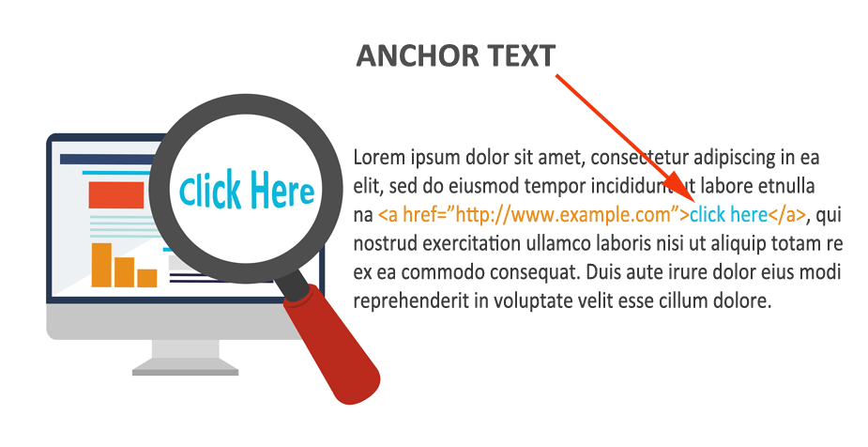
So an example (for the link https://woww.co.za/wordpress-seo-services/) of bad anchor text is “Click HERE!” and a good anchor text is “Woww SEO services” (branded partial-match anchor text relevant to the link). Some of your anchors will be generic due to their nature (e.g. menu headers, “contact us”, etc.) and this isn’t a problem.

Anchor text shouldn’t be longer than about 60 characters (unless it’s a naked URL).

Anchor text isn’t only applicable to the links on your website. Anchor text is also applicable to other websites’ links to your site (backlinks). You want the majority of your backlinks to your site to be branded anchors (~70%) and then naked link anchors (~20%).

The remaining 10% of anchors can be generic, partial-match, and exact-match. What you want to avoid is ‘over-optimisation’ - i.e. too many exact-match (or partial-match) backlinks (because Google would view this as spam - as you trying to cheat the system).

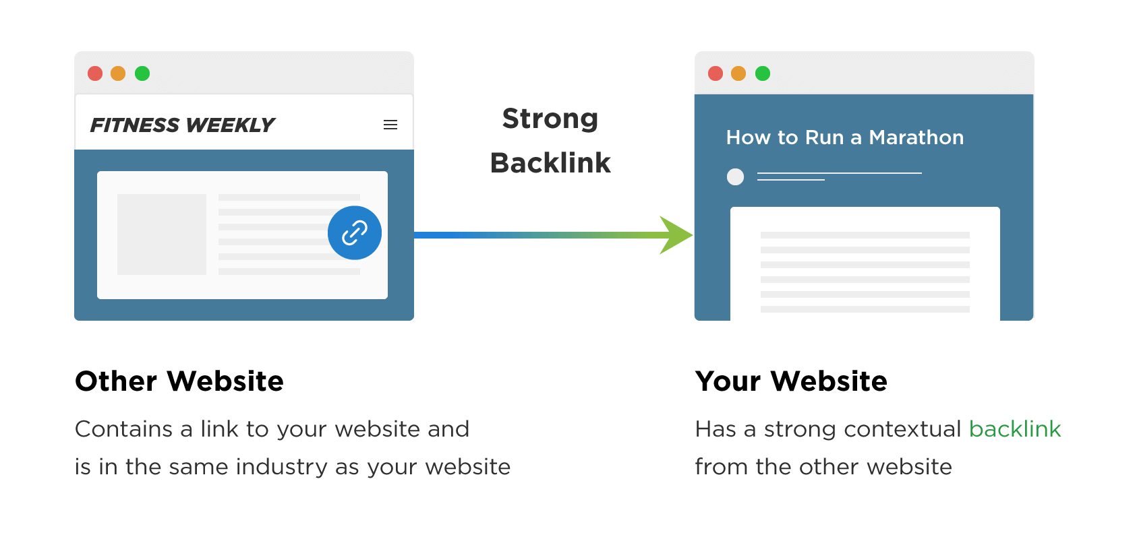
DATA COLLECTION

 | Anchor Text

FINDINGS

- Some anchor text is clear and relevant.
  - Examples include Gaming Board, Gaming Act 2014, Regulations and Rules, Responsible Gaming, Privacy Policy, Sign Up, and Results.
  - These anchors help users understand where the link will take them.
- Anchor text is heavily weighted toward navigation, footer, and utility links.
  - Common anchors include How To Play, About Us, Cookies, FAQs, Privacy Policy, Home, Desktop Site, and Mobile Site.
  - This means the internal link profile is not doing much to reinforce key SEO themes such as lottery results, winning numbers, online casino, sportsbook, or sign-up intent.
- 12 links have blank anchor text.
  - These are mainly social links to Instagram and Facebook.
  - Blank anchors are weaker for accessibility and do not clearly describe the link destination.
- Several anchors are generic.
  - Examples include Home, Logo, click here, (click here), Desktop Site, and Mobile Site.
  - These provide limited context to users and search engines.
- Some anchor text points to redirecting URLs.
  - 17 linked URLs return a 302 status.
  - These include anchors such as Home, Desktop Site, Mobile Site, and click here.
  - Internal links should point directly to the final destination where possible.
- There is limited keyword-led internal anchor text for important pages.
  - The site has rankings around lottery results, winning numbers, casino, sportsbook, and Paradise Games branded terms.
  - However, the anchor text does not strongly support these page themes.
- One broken link uses non-descriptive anchor text.
  - Source URL: https://classic.pggames.com/Mobile/Terms
  - Anchor text: (click here)
  - Broken target: https://classic.pggames.com/Mobile/~/Images/Gamingbill2014.pdf
  - This should be fixed because it combines a broken destination with weak anchor text.

RECOMMENDATIONS
- Replace generic anchor text with descriptive anchor text where possible.
  - Replace click here / (click here) with the actual destination or action.
  - For example, use Gaming Act 2014 PDF, Paradise Games Terms and Conditions, or View Lottery Results.
- Add more descriptive internal links to priority pages.
  - Use anchors such as Lottery Results, Winning Numbers, Check Lottery Results, Sign Up for Paradise Games, Online Casino, and Sportsbook.
  - This will help reinforce the intended purpose of each key page.
- Add accessible labels to social links.
  - For example, use Paradise Games on Instagram and Paradise Games on Facebook.
  - This is better for accessibility and avoids blank anchor text.
- Update redirecting internal links so they point directly to final 200-status URLs.
  - This applies especially to Home, Desktop Site, Mobile Site, and switch-related links.
- Fix the broken Terms page link and update its anchor text.
  - The broken (click here) link should either be corrected to a live PDF or removed.
  - If retained, use descriptive anchor text such as Gaming Act 2014, Regulations and Rules.
- Use anchor text to support the site’s main silos.
  - Results-related pages should be linked with anchors around Lottery Results and Winning Numbers.
  - Casino pages should be linked with anchors around Online Casino and Casino Games.
  - Sportsbook pages should be linked with anchors around Sportsbook and Sports Betting.
  - Sign-up/account pages should be linked with clear conversion-led anchors such as Sign Up or Create an Account.

On Page Content

lON PAGEl lCONTENTl
The content (or “copy”) of a page is very important. Weak content with strong optimization won’t perform. Strong content without effective optimization also won’t perform. You need both strong content and effective optimization to drive search engine traffic.

“Content” can refer to blog posts and guides, but it can also refer to any on page text, notably such as product descriptions and service descriptions. It’s not uncommon to see websites which are willing to write somewhat lengthy blog posts but fail to write adequately long product or service descriptions.

Correlation Analysis
In this subsection we use a correlational SEO service to analyse 3 pages on your site. This allows us to analyse the keyword usage on the page from a more analytical perspective. This is also useful because it gives an overview of each page as the sum of its components, rather than looking at each of the components individually (as has been done above). The recommendations should be taken with a grain of salt.

- Home page: https://pggames.com/
- Results page: https://classic.pggames.com/Mobile/Results

DATA COLLECTION

 | Home page (Target keyword: online betting Bahamas)
 | Home page (Target keyword: online casino Bahamas)
 | Results page (Target keyword: lottery results)
 | Results page (Target keyword: winning numbers)

FINDINGS

- The homepage TTFB is within the optimal range for both homepage analyses.
- Internal linking to the Results page appears to be sufficient according to the Surfer analysis.
  - Both Results page audits state that relevant pages already contain internal links.
- The homepage has low content depth compared with competing pages.
  - For online betting Bahamas, the homepage has 366 words in the body, while the suggested range is 2,211 to 4,974 words.
  - For online casino Bahamas, the homepage has 366 words in the body, while the suggested range is 1,738 to 3,836 words.
  - This supports the recommendation to expand the homepage with concise sections covering lotto, casino, sportsbook, results, promotions, and sign-up.
- The homepage does not have enough supporting heading structure.
  - It has 0 words in H2-H6 headings for both analyses.
  - Surfer suggests 120 to 261 words in H2-H6 headings for online betting Bahamas.
  - Surfer suggests 89.4 to 261 words in H2-H6 headings for online casino Bahamas.
- The homepage is missing the exact target keyword in key on-page areas.
  - The exact keyword is not present in the title.
  - The exact keyword is not present in the H1.
  - The exact keyword is not present in the body.
  - This applies to both online betting Bahamas and online casino Bahamas.
- The Results page has some body content, but most of it does not appear to be structured as useful paragraph copy.
  - For lottery results, the page has 1,360 words in the body, while the suggested range is 2,762 to 13,449 words.
  - For winning numbers, the page has 1,360 words in the body, while the suggested range is 1,714 to 6,828 words.
  - However, the page only has 19 words in paragraph text across both analyses, which suggests much of the content may be table/interface-led rather than explanatory content.
- The Results page has weak heading structure.
  - It has 0 H1 elements.
  - It has only 1 H2-H6 element.
  - The page should include a clear H1 and supporting headings for lottery results, winning numbers, today’s results, and previous results.
- The Results page is missing the target keyword in key on-page areas.
  - lottery results is not present in the title or H1.
  - winning numbers is not present in the title, H1, or body at the recommended level.
- The homepage load time is slightly above the recommended range for online betting Bahamas.
  - Load time is 4,925ms, which is 147ms higher than Surfer’s recommended maximum.
  - This is minor compared with the content and structure issues.
- The Results page TTFB is significantly above the recommended range.
  - For lottery results, TTFB is 3,011ms, which is 2,071ms higher than the recommended maximum of 940ms.
  - For winning numbers, TTFB is 3,039ms, which is 2,233ms higher than the recommended maximum of 806ms.
  - This should be reviewed because slow server response can affect crawl efficiency, user experience, and page performance.

RECOMMENDATIONS
- Prioritise “online betting Bahamas” as the homepage’s primary target keyword.
  - Use online casino Bahamas as a supporting term, or assign it to a dedicated casino page if one is intended to be indexable.
  - The homepage should reflect the full Paradise Games offering, not only casino.
- Expand homepage content in a structured way.
  - Add concise sections for lotto, lottery results, online casino, sports betting, promotions, sign-up, and responsible gaming.
  - Do not add thousands of words purely to match Surfer’s suggested range; focus on useful content that supports user intent and conversion.
- Improve homepage keyword alignment.
  - Add the primary target keyword or a close variation to the title, H1, and introductory body copy.
  - Suggested H1: Online Betting in The Bahamas
  - Suggested title direction: Paradise Games | Online Betting, Lotto, Casino & Sportsbook Bahamas
- Improve the Results page structure and content.
  - Add a clear H1 such as Lottery Results & Winning Numbers.
  - Add supporting sections such as:
    - Today’s Lottery Results
    - Latest Winning Numbers
    - Previous Results
    - How to Check Lottery Results with Paradise Games
  - Add short explanatory paragraph copy around the results data so the page is not only table/interface-led.
- Improve Results page keyword alignment.
  - Use lottery results as the primary keyword.
  - Use winning numbers as a close supporting keyword.
  - Include both naturally in the title, H1, intro copy, and internal links.
- Review server response time for the Results page.
  - The homepage TTFB is fine, so this appears to be more specific to the Results page/mobile results setup.
  - Investigate whether the Results page is slowed by dynamic result loading, backend calls, mobile/classic infrastructure, redirects, or server-side rendering delays.
- Refer to the content length, heading structure, title, meta description, internal linking, and technical performance sections for supporting implementation recommendations.

Content Length
It is important to have long content. The length will depend on the content type, for example:
- A product description might be 50-150 words
- A service description might be 300-500 words (or more)
- An evergreen piece of content might be 750-1000 words
- An in-depth guide might be 3000-4000 words (or more)

These are more guidelines than strict rules and the suggestions will vary depending on the context, but generally more is better. Blog posts should generally be 1000 words at least - anything lower is likely going to be too threadbare.

DATA COLLECTION

 | Content length

FINDINGS

- Some pages have enough content to suit their likely purpose.
  - The contact support pages have 2,685 words.
  - The Terms page has 7,106 words.
  - These pages do not need additional copy for SEO purposes unless the content is unclear, outdated, or poorly structured.
- Several important indexable pages are thin or light on useful content.
  - https://classic.pggames.com/Mobile/Results has 197 words.
  - https://classic.pggames.com/Mobile/RecoverPin has 148 words.
  - https://classic.pggames.com/Mobile/ has 128 words.
  - https://pggames.com/footer and https://www.pggames.com/footer each have 190 words.
- The homepage has a moderate amount of content, but it still needs better SEO-focused structure.
  - https://pggames.com/ has 1,078 words.
  - https://www.pggames.com/ has 1,078 words.
  - The issue is less about raw word count and more about whether the content clearly supports lotto, casino, sportsbook, results, promotions, sign-up, and responsible gaming.
- The Results page is too light for a page targeting lottery results and winning numbers.
  - It should include more explanatory content around today’s results, previous results, winning numbers, and how users can check results.
  - This does not need to become a long article, but it should provide enough context to match search intent.

RECOMMENDATIONS
- Do not add content purely to increase word count.
  - Content should only be added where it improves page purpose, search intent match, trust, or user experience.
- Create or improve dedicated subpages for the main keyword themes rather than trying to make the homepage rank for everything.
  - The homepage should target the broader brand and online betting Bahamas theme.
  - A dedicated casino page should target online casino Bahamas, casino games, and related casino terms.
  - A dedicated sportsbook/sports betting page should target sports betting Bahamas, sportsbook, and related sports betting terms.
    - You could also consider creating dedicated pages for betting on different types of sport i.e NBA, NFL, Premier League, etc.
  - The Results page should target lottery results, winning numbers, and related result-led terms.
  - Dedicated lotto/product pages should be considered for lotto products, draw types, promotions, and how-to-play content where relevant.
- Improve the homepage content structure.
  - Add short descriptive content blocks for each main offering:
    - Lotto and Lottery Results
    - Online Casino
    - Sportsbook
    - Promotions
    - Sign Up / Account Access
    - Responsible Gaming
  - These blocks should briefly describe each offering and link to the relevant subpage.
  - The homepage should introduce each offering, not explain everything in full.
- Expand the Results page.
  - Add a short introduction explaining that users can check Paradise Games lottery results and winning numbers.
  - Add supporting sections such as:
    - Today’s Lottery Results
    - Latest Winning Numbers
    - Previous Results
    - How to Check Paradise Games Results
  - Add internal links to relevant lotto/product pages and sign-up pages.
- Add short, useful FAQ sections to priority pages where they support search intent.
  - Results page FAQ examples:
    - How do I check Paradise Games lottery results?
    - Where can I find today’s winning numbers?
    - How often are lottery results updated?
    - Can I view previous winning numbers?
  - Casino page FAQ examples:
    - Can I play casino games online in The Bahamas?
    - What casino games are available?
    - Can I try casino games before playing for real money?
  - Sportsbook page/sports betting FAQ examples:
    - Can I bet on sports online in The Bahamas?
    - What sports can I bet on?
    - How do I check sports betting odds?
- Use subpages to add useful topic-specific content.
  - This will allow each page to go into more depth without overloading the homepage.
  - It will also help Google understand which page should rank for each keyword theme.
- Link these pages together using descriptive internal links.
  - Use anchors such as:
    - View Lottery Results
    - Play Online Casino Games
    - Explore Sports Betting
    - Create an Account
    - View Promotions
  - This will support both user journeys and topical relevance.
- Review thin functional pages before adding more content.
  - If pages such as Recover PIN, footer, and mobile entry are not intended to rank, consider whether they should remain indexable.
  - If they are intended to remain indexable, add concise explanatory copy and stronger headings.
- Use content length recommendations alongside the content quality and search intent section.
  - Word count should be treated as a guide, not the main optimisation goal.
  - FAQs, short descriptions, improved headings, and better internal links are the preferred way to increase useful content depth.

Content Quality & Search Intent
It is important to have high quality content. However, it is more important to satisfy search intent. Satisfying search intent refers to the ability of the page to provide users with the content they were searching for.

E.g. the keywords "iphone review" (informational) and "iphone south africa" (commercial) have different search intent - a purely informational page shouldn’t rank for commercial keywords and vice versa.

Once your search intent is adequately appropriate then the focus must turn to content quality - you need high quality to beat the other search results. Both content quality and search intent will be subjectively analysed for a sample of recent pages.

FINDINGS

- Paradise Games has clear core service areas that can support strong SEO content.
  - These include lotto/results, online casino, sportsbook, promotions, account access, and responsible gaming.
  - These topics are relevant to the keyword research and the likely needs of users searching in The Bahamas.
- The homepage does not clearly satisfy one focused search intent.
  - It currently needs to introduce the full Paradise Games offering, but it should not be expected to rank well for every casino, sportsbook, lotto, and results-related keyword.
  - The homepage is better suited to broader brand and online betting Bahamas intent.
- The Results page partially matches search intent, but lacks enough supporting context.
  - Users searching for lottery results or winning numbers want quick access to results.
  - However, the page should also explain what results are shown, how often they are updated, how to check previous results, and what users should do next.
- Some important keyword themes do not appear to have strong dedicated indexable pages.
  - online casino Bahamas should be targeted by a dedicated casino page.
  - sports betting Bahamas should be targeted by a dedicated sportsbook page.
  - Lotto product/draw terms may also need dedicated supporting pages if Paradise Games wants to compete for those searches.
- Content is currently more functional than explanatory.
  - Several pages appear to focus on actions such as login, results, sign-up, or account recovery.
  - This is useful for existing users, but it limits SEO value because pages do not provide enough context for new users or search engines.
- The site would benefit from more trust and compliance-led content.
  - This is especially important because Paradise Games operates in the gambling sector.
  - Users and search engines need clear information around responsible gaming, account support, terms, privacy, and regulatory credibility.
- N/A

RECOMMENDATIONS
- Create or improve dedicated pages for each major search intent, rather than relying on broad pages to cover everything.
  - Homepage: broad brand and online betting Bahamas intent.
  - Results page: lottery results and winning numbers intent.
  - Casino hub page: online casino Bahamas and general casino intent.
  - Sportsbook hub page: sports betting Bahamas, sportsbook, and betting intent.
  - Lotto hub/page: lotto products, draw types, how to play, and result-led journeys.
- Create dedicated casino subpages for specific game types where they match Paradise Games’ offering.
  - Slots / online slots
  - Table games
  - Blackjack
  - Roulette
  - Live casino
  - Demo casino games, if available
  - Casino providers or game collections, if relevant
- Create dedicated sportsbook subpages for specific betting intents.
  - NFL betting
  - NBA betting
  - Football / Premier League betting
  - Live betting
  - Betting odds
  - Sports betting promotions, if relevant
- Create dedicated lotto/result-led pages where there is enough demand and product relevance.
  - Lottery results
  - Winning numbers
  - Today’s results
  - Previous results
  - How to play lotto
  - Lotto promotions or draw-specific pages
- Make each page match a specific user intent.
  - Game pages should explain what the game is, how users can play, and what options are available.
  - Sports betting pages should explain available markets, odds, supported sports, and how to place bets.
  - Results pages should prioritise fast access to results, with supporting copy and FAQs.
  - Promotional pages should clearly explain eligibility, terms, and next steps.
- Avoid making the homepage too broad or too long.
  - The homepage should introduce each main offering with short descriptions.
  - More detailed content should live on the relevant subpages.
  - This will help search engines understand which page should rank for each keyword theme.
- Add FAQs to the main commercial and informational pages.
  - Casino FAQs should cover available games, online play, demo options, account access, and responsible gaming.
  - Sportsbook FAQs should cover sports, odds, live betting, account requirements, and bet placement.
  - Results FAQs should cover checking results, winning numbers, update frequency, and previous results.
- Strengthen trust and compliance across all gambling-related content.
  - Include responsible gaming references where appropriate.
  - Link to terms, privacy policy, support, and regulatory information.
  - Avoid unsupported promotional claims or language that could create compliance issues.

Content Ideas
We strongly advise that you not create content just for the sake of content. Content must be backed up by search volume (things people are searching for). Content must have a promotion strategy. Do not publish and pray, rather publish and promote.

Content must be of the highest quality - go for fewer high quality pieces and put more effort into promotion of that content (otherwise, it becomes dead weight).

The types of content which we would advise for you are detailed here:


Short Form Evergreen Content
lCONTENTl lIDEASl
Short Form Evergreen Content
General answers to topics and questions asked on a regular basis, these are the pages which don’t really need to be updated once created. 300-800 Words

There are plenty of evergreen topics you could write about and publish on your blog.

Here are some examples:

- How do I check lottery results online?
- Where can I find today’s winning numbers?
- What is the difference between lottery results and winning numbers?
- How often are lottery results updated?
- How do lottery numbers work?
- How are lottery numbers drawn?
- How do I check if my lottery ticket is a winner?
- How do I play lottery online?
- How do I buy lottery tickets online?
- How old do you have to be to buy a lottery ticket?
- How long do you have to redeem a lottery ticket?
- What are online casino games?
- What are the most popular casino games?
- How does online gambling work?
- What is a live casino?
- What is an online casino bonus?
- What casino games have the best odds?
- How do sports betting odds work?
- What is moneyline betting?
- What is spread betting?
- What is a sportsbook?
- What does no action mean in sports betting?
- What is draw no bet in soccer betting?
- What is 1X2 betting in football?
- What does handicap mean in soccer betting?
- What is over 1.5 in soccer betting?

Long-form articles
Long-form articles | Woww guide included below
Mega posts that are incredibly in depth. These are goldmines for keywords and also are likely to be shared if the quality is high. These are articles that explain a concept in depth with images and media, related sources, resources, discusses the topic in great detail, etc (eg: 2500-5000+ words).

For example:
- Ultimate guides:
  - The Ultimate Guide to Rosehip Oil
  - Ultimate Guide to Surgical Films:
  - The Ultimate Acne Guide
  - Ultimate Guide: Find student jobs in Cape Town

- How to guides:
  - Domain Authority: How to boost it for your website
  - How to measure ROI for marketing campaigns

This is consistently recommended by all SEO experts as the key to SEO right now.
Here are some examples:

- The Ultimate Guide to Lottery Results and Winning Numbers
- The Ultimate Guide to Playing Lottery Online
- The Ultimate Guide to Online Casino Games in The Bahamas
- The Ultimate Guide to Slots, Roulette, Blackjack and Live Casino
- The Ultimate Guide to Sports Betting in The Bahamas
- The Ultimate Guide to Understanding Betting Odds
- The Ultimate Guide to Football Betting Terms
- The Ultimate Guide to Responsible Gaming

Having one mega post could potentially drive traffic (over the long run too, if it’s written in a more timeless fashion). You could then link to other pages on your site (as appropriate).

Here’s a step by step guide on how to write one of these pieces of content:

How to Write The Ultimate Guide

Infographics
Infographics | Woww guide included below
An infographic is a collection of imagery, charts, and minimal text that gives an easy-to-understand overview of a topic.
Using infographics strategically can be incredibly powerful to gain exposure and backlinks.

You can create Infographics with statistics related to your topic.

For example:
- How to Check Lottery Results and Winning Numbers
- Lottery Results vs Winning Numbers: What’s the Difference?
- How Lottery Numbers Are Drawn
- How to Read a Lottery Ticket
- Online Casino Games Explained: Slots, Roulette, Blackjack & Live Casino
- How Sports Betting Odds Work: Moneyline, Spread & Totals
- Football Betting Terms Explained: 1X2, Draw No Bet, Handicap & Over/Under
- Responsible Gaming: Tips for Playing Safely
You then share this with:
- The Nassau Guardian
https://thenassauguardian.com/
- The Tribune
https://www.tribune242.com/
- Eyewitness News Bahamas
https://ewnews.com/
- The Sports Magazine Bahamas
https://sportsmagazinebahamas.com/
- CaribLetiX
https://www.caribletix.com/
- Wybe Magazine
https://wybemag.com/
- Bahamas Gaming Operators Association
https://bgoabahamas.com/
- Focus Gaming News
https://focusgn.com/
- Gambling Insider
https://www.gamblinginsider.com/
- NEXT.io
https://next.io/

This type of asset can be especially effective when tied to a timely or educational angle, such as major sporting events, lottery results, online betting education, casino game explainers, or responsible gaming awareness.

The value exchange is straightforward: publishers receive a high-quality visual asset that is useful to their audience, while Paradise Games gains brand exposure, referral traffic, and a relevant backlink where credited as the original source.

Here’s a step by step guide for Creating An Infographic.

The Infographic - Step by Step Guide

Guest Articles
Guest Articles
Get industry experts to create awesome content for your website. Or, do the inverse and be the authority, and write guest articles for other sites and get them to provide you with a valuable backlink.

E.g: You could offer to write a guest article on:

- The Nassau Guardian
https://thenassauguardian.com/
- The Tribune
https://www.tribune242.com/
- Eyewitness News Bahamas
https://ewnews.com/
- The Sports Magazine Bahamas
https://sportsmagazinebahamas.com/
- CaribLetiX
https://www.caribletix.com/
- Wybe Magazine
https://wybemag.com/
- Bahamas Gaming Operators Association
https://bgoabahamas.com/
- Focus Gaming News
https://focusgn.com/
- Gambling Insider
https://www.gamblinginsider.com/
- NEXT.io
https://next.io/

Backlinks from relevant websites in the Bahamas, Caribbean, sports, entertainment, responsible gaming, and regulated iGaming spaces can be valuable because they are topically aligned and can introduce the brand to potential users earlier in the journey.

Legal note: outreach to gambling or iGaming publications should be reviewed carefully. Guest articles should avoid unsupported claims, guaranteed-win language, or promotional statements that may create compliance issues.

List Posts
List Posts | Woww guide included below
People love lists. Just be careful not to make content completely unrelated to your business (e.g. you have a popular list “10 easy tips to save water” which is a great article which drives traffic, but that traffic isn’t going to convert, because it’s completely unrelated).

These types of content are highly digestible due to their format, allow for easy population of relevant keywords when discussing the list items, and are easy to share.

They are also prime candidates for vanity sharing (easy backlinks).
Here are some ideas for list posts that you could write:

- 10 Things to Know Before Playing Online Casino Games
- 10 Popular Casino Games Explained
- 10 Online Slots Terms Beginners Should Know
- 10 Sports Betting Terms Every Beginner Should Know
- 10 Football Betting Terms Explained
- 10 Things to Know Before Placing a Sports Bet
- 10 Responsible Gaming Tips for Online Players
- 10 Common Lottery Terms Explained
- 10 Things to Check When Reviewing Lottery Results
- 10 Questions New Paradise Games Players May Have

List posts can be written differently, short or incredibly long, and with more or less meat per list item. Here are step by step guides on how to write three types of List Posts:

How to Write The Assembled List Post

How to Write The Padded List Post

How to Write The Ultimate List

How to Guides
How to Guides | Woww guide included below
How to Guides offer incredibly actionable tips and advice for your audience.
Here are some great examples you could write about:

- How to Check Lottery Results and Winning Numbers Online
- How to Read a Lottery Ticket
- How to Play Lottery Online
- How to Get Started With Online Casino Games
- How to Play Slot Games
- How to Play Blackjack Online
- How to Play Online Roulette
- How to Understand Sports Betting Odds
- How to Read Moneyline, Spread, and Total Bets
- How to Get Started With Sports Betting

These are two guides on how to write a highly actionable guide for your audience to follow.

These may not be entirely relevant to every topic you come up with but these guides still provide a good approach to putting together a How To Guide post.

How to Write The Step by Step Guide

How to Write The Yearly Manual

Roundups
Roundups | Woww guide included
Are a great tool to generate content. You can create a roundup list of relevant people or organizations, these are basically lists on steroids.
For example:
- 10 Biggest Sports Events to Watch in The Bahamas This Year
- 10 Major Football Fixtures to Follow This Season
- 10 Major Basketball Games to Watch This Season
- 10 Top Sporting Events for Bahamas Sports Fans
- 10 Best Bahamas Sports Clubs and Teams to Follow
- 10 Top Entertainment Events to Look Out for in The Bahamas
- 10 Best Venues for Sports Fans in The Bahamas
- 10 Top Responsible Gaming Resources in The Bahamas and the Caribbean
- 10 Major Casino Game Types Available Online
- 10 Best Online Casino Games for Beginners
- Examples of gambling-site roundups, subject to legal review:

- 10 Best Gambling Sites in The Bahamas
- 10 Best Online Casinos in The Bahamas
- 10 Best Sports Betting Sites in The Bahamas
- 10 Best Online Betting Sites in The Bahamas
- 10 Best Casino Apps in The Bahamas

Here are guides for creating two types of roundup posts. These are especially helpful Content Frameworks to use when you’re just getting started or when you’re trying to expand your network and build relationships.

How to Write The Gathered Experts Guide

How to Write The Recognition Lure

Experts that contribute will be happy to share your page with their audience. Which means you can get A LOT of traffic very quickly, even if your site is brand new.

Versus Posts
Versus posts are excellent for comparison-based content that helps readers make informed decisions. These posts directly compare two products, tools, ingredients, or concepts — showing their similarities, differences, and which one is better suited for specific needs.

They’re especially effective for driving decision-stage traffic, building topical authority, and improving LLMO performance, as comparison content aligns naturally with the way large language models interpret and summarise nuanced trade-offs between options.

- Brands / systems on-site
  - Paradise Games Mobile vs Desktop Site: Which Should Players Use?
  - Paradise Games Sign Up vs Login: What’s the Difference?
  - Paradise Games Results Page vs Mobile Results Page: Where Should Users Check Winning Numbers?
  - Paradise Games Casino vs Paradise Games Sportsbook: Which Is Right for Your Playing Style?

- Betting types
  - Online Betting vs In-Store Betting: What’s the Difference?
  - Lotto Betting vs Sports Betting: Which Is Easier for Beginners?
  - Casino Games vs Sports Betting: Key Differences for New Players
  - Live Betting vs Pre-Match Betting: What’s the Difference?
  - Single Bets vs Parlay Bets: Which Should Beginners Understand First?

- Casino game comparisons
  - Slots vs Table Games: Which Casino Game Type Is Best for Beginners?
  - Blackjack vs Roulette: What’s the Difference?
  - Online Slots vs Live Casino Games: Which Experience Suits You?
  - Demo Casino Games vs Real Money Casino Games: What Should Players Know?
  - Roulette vs Slots: Which Casino Game Is Easier to Understand?

- Sports betting comparisons
  - Moneyline vs Spread Betting: What’s the Difference?
  - Over/Under vs Moneyline: Which Sports Bet Is Easier to Understand?
  - 1X2 Betting vs Draw No Bet: Football Betting Terms Explained
  - Handicap Betting vs Over/Under Betting: What’s the Difference?
  - NBA Betting vs NFL Betting: How Do the Markets Differ?
  - Football Betting vs Basketball Betting: Key Differences for Beginners

- Sports betting comparisons
  - Moneyline vs Spread Betting: What’s the Difference?
  - Over/Under vs Moneyline: Which Sports Bet Is Easier to Understand?
  - 1X2 Betting vs Draw No Bet: Football Betting Terms Explained
  - Handicap Betting vs Over/Under Betting: What’s the Difference?
  - NBA Betting vs NFL Betting: How Do the Markets Differ?
  - Football Betting vs Basketball Betting: Key Differences for Beginners

- Lotto / results comparisons
  - Lottery Results vs Winning Numbers: What’s the Difference?
  - Today’s Results vs Previous Results: Which Should You Check?
  - Lotto Numbers vs Lottery Results: Are They the Same?
  - Online Lottery Results vs In-Store Result Checking: What’s the Difference?
  - Lotto Betting vs Casino Games: How Are They Different?

- Responsible gaming / safety comparisons
  - Responsible Gaming vs Problem Gambling Support: What’s the Difference?
  - Setting Betting Limits vs Taking a Break: Which Option Helps Players Stay in Control?
  - Playing for Fun vs Chasing Losses: What Players Should Know
  - Casino Bonuses vs Responsible Gaming Limits: What Should Players Consider?

- Competitor-style versus posts
  - Paradise Games vs Island Luck: What’s the Difference?
  - Paradise Games vs Chances: What’s the Difference?
  - Paradise Games vs Asurewin: What’s the Difference?
  - Paradise Games vs Ultra Games: What’s the Difference?
  - Paradise Games Casino vs Island Luck Casino: What Should Players Know?
  - Paradise Games Sportsbook vs Other Bahamas Sports Betting Sites
    - Legal review recommended before publishing. Keep factual, avoid unsupported “best” claims, and include licensing/responsible gaming context.

OptimisationsLanding Page Ideas
Landing Page Ideas
You may consider creating landing pages that target highly relevant long-tail searches around lotto results, online casino games, sportsbook betting, game providers, and local Bahamas betting intent. These terms may individually have modest search volume, but they are closely aligned with commercial intent and can help capture more specific searches from users looking for a particular type of game, betting option, result, or online gambling service.

These pages should be created carefully due to the gambling niche. Landing pages should include responsible gaming messaging, age restrictions, clear terms where relevant, and legal/compliance review before publication.

Lotto / winning numbers pages
There are result-led and lotto-related terms that could be better targeted through dedicated landing pages. Examples from the keyword research and onboarding answers include:

winning numbers
lottery results
lottery post
lotto results
lottery results today
winning number today
lottery numbers
lottery winning numbers
lotto numbers
3-ball miami

Suggested landing pages:
- Lottery Results
- Winning Numbers
- Today’s Winning Numbers
- Lotto Results
- Lottery Numbers
- 3-Ball Miami Results
- How to Check Lottery Results Online
- How to Play Lotto Online

These pages should prioritise fast access to results, clear update information, previous results where relevant, and internal links to sign-up, account access, and responsible gaming pages.

Online casino pages
There are casino-related terms that could be targeted through dedicated landing pages rather than relying on the homepage to rank for all casino intent. Examples include:
- online casino
- online casino bahamas
- casino online real money
- casino games
- online casino games
- casino games demo
- live casino
- online gambling

Suggested landing pages:
- Online Casino Bahamas
- Online Casino Games
- Casino Games
- Live Casino
- Casino Games Demo
- Real Money Casino Games
- Online Gambling Bahamas

These pages should explain the available casino offering, link users to the most relevant games or account pages, and include responsible gaming and legal/age restriction messaging. Claims around “real money”, bonuses, or game availability should be checked before publication.

Casino game type pages
There are also game-specific casino terms that could support dedicated landing pages.

Examples include:
online blackjack
blackjack online
online roulette
roulette online
online slots
slot games
casino slots
crazy time
crazy time demo
multislot games
multi slots
multi slots demo
pragmatic play games
evolution games

Suggested landing pages:
- Online Blackjack
- Online Roulette
- Online Slots
- Slot Games
- Crazy Time
- Crazy Time Demo
- Multi Slots
- Multi Slots Demo
- Pragmatic Play Games
- Evolution Games
- Casino Table Games

These pages would work best where the games are genuinely available through Paradise Games. Each page should explain the game, how users can access it, whether demo play is available, and any key responsible gaming considerations.

Sportsbook / sports betting pages
There are sportsbook and sports betting terms that could be better supported through dedicated landing pages. Examples include:
online sports betting
sports betting bahamas
online betting
sportsbook
sports betting
sports betting odds
sports betting picks
nba betting
nba odds
nfl betting
nfl odds
premier league betting
football betting
soccer betting

Suggested landing pages:
- Online Sports Betting Bahamas
- Sportsbook Bahamas
- Sports Betting Odds
- NBA Betting
- NBA Odds
- NFL Betting
- NFL Odds
- Premier League Betting
- Football Betting
- Soccer Betting
- Live Betting

These pages should explain the relevant betting markets, available sports, how odds work, and how users can place bets. Avoid publishing betting advice that implies guaranteed outcomes. Pages around picks, predictions, or odds should be reviewed carefully from a legal and responsible gaming perspective.

Provider / game collection pages
Paradise Games specifically noted provider and game-related keywords such as Pragmatic Play, Evolution, multislot games, and Crazy Time. These can support landing pages where Paradise Games has the relevant games or provider access.

Suggested landing pages:
- Pragmatic Play Games
- Evolution Games
- Evolution Live Casino
- Crazy Time
- Multi Slots Games
- Live Casino Providers
- Casino Providers Bahamas

These pages should only be created where the provider/game relationship is accurate and permitted from a brand/legal perspective. They should also avoid implying official partnership status unless this is contractually correct.

Location / service area pages
Paradise Games is currently targeting The Bahamas and may expand into the Caribbean in future. Location-based landing pages may help capture users searching for local online betting, casino, lotto, or sportsbook services.

Suggested landing pages:
- Online Betting Bahamas
- Online Casino Bahamas
- Sports Betting Bahamas
- Lotto Bahamas
- Nassau Online Betting
- Freeport Online Betting
- Online Betting Caribbean
- Online Casino Caribbean
- Sports Betting Caribbean

These pages should not just swap out the location name. Each one should include location-relevant copy, store/deposit/withdrawal information where relevant, legal availability, user support details, and internal links to the most relevant service pages.
Deposit, withdrawal and store pages.

Paradise Games offers depositing and withdrawing at 40+ stores, as well as electronic funds transfer. This is a useful differentiator and could support user-focused landing pages.

Suggested landing pages:
- Paradise Games Store Locations
- Deposit and Withdraw at Paradise Games Stores
- How to Deposit With Paradise Games
- How to Withdraw From Paradise Games
- Online Betting With EFT Deposits
- Paradise Games Account Funding Guide
These pages should clearly explain user options, requirements, processing times where applicable, and support routes. Any financial, account, or withdrawal claims should be checked for accuracy before publication.

Competitor comparison landing pages
The onboarding answers identify Island Luck, Chances, Ultra Games, A Sure Win, Everybody Wins Live, and The Island Game as important competitors. Competitor-led pages may be useful, but they require careful legal and compliance review.

Suggested landing pages:
- Paradise Games vs Island Luck
- Paradise Games vs Chances
- Paradise Games vs Ultra Games
- Paradise Games vs A Sure Win
- Paradise Games vs Everybody Wins Live
- Paradise Games vs The Island Game

Legal review is strongly recommended before publishing competitor comparison pages. These pages should be factual, neutral, evidence-backed, and avoid unsupported superiority claims. They should include clear comparison criteria and responsible gaming messaging.

Final thoughts on content creation

Final thoughts on content creation
Pages must have purpose: Paradise Games has clear SEO opportunities across lotto, winning numbers, online casino, and sports betting, but these should not all be forced onto the homepage. Improving the quality, usefulness, SEO value, and conversion potential of the pages that matter most should be the priority.

In particular, the homepage, Results page, and any dedicated Casino, Sportsbook, Lotto, Sign Up, and store/deposit pages should be treated as priority pages. The homepage should act as a clear gateway into the main offering, while dedicated subpages should target more specific search intent such as lottery results, winning numbers, online casino Bahamas, online sports betting, online blackjack, online roulette, multi slots, NBA betting, and NFL betting.

For a gambling website, content should also be reviewed through a compliance and trust lens. Pages should include clear responsible gaming messaging, age restrictions where relevant, accurate product information, and links to terms, support, and regulatory information. Avoid creating content that implies guaranteed wins or encourages irresponsible play.

Be thoughtful about linking: Internal linking should be used much more deliberately to strengthen the most important landing pages and topic clusters.
One of the clearest opportunities is to use short descriptions, FAQs, and contextual links on the homepage and supporting pages to connect users to the most relevant sections of the site. For example, the homepage should link clearly to Lottery Results, Online Casino, Sportsbook, Promotions, Sign Up, store/deposit information, and Responsible Gaming pages.

Blog and educational content should also be organised into clearer topic clusters around lotto/results, casino games, sportsbook betting, responsible gaming, and account support. These articles should link back into the relevant commercial or functional pages using descriptive, keyword-relevant anchor text. This is particularly important for helping deeper pages build more topical authority and for guiding users from informational content into sign-up or play-focused pages.

Carefully consider keywords: Continue to prioritise keywords that reflect clear search intent and the way users in The Bahamas actually search for gambling, lotto, and betting services. For Paradise Games, this includes terms such as winning numbers, lottery results, lottery post, online casino, online casino Bahamas, online sports betting, sports betting Bahamas, pragmatic play games, evolution games, multislot games, crazy time, online blackjack, online roulette, NBA betting, NFL betting, and Premier League betting.
Competitor-led terms such as Island Luck, Chances, Ultra Games, A Sure Win, Everybody Wins Live, and The Island Game may also represent search demand, but content targeting these terms should be handled carefully and legally reviewed before publication.

Create landing pages and supporting content where there is a genuine page purpose. The clearest landing page opportunities are around lotto/results, online casino, casino game types, sportsbook/sport-specific betting, provider/game collections, Bahamas/local betting intent, deposit/withdrawal/store information, and carefully reviewed competitor comparisons.

Publish Roundup posts, Versus posts, Ultimate Guides, How-to Guides, and short evergreen articles only where they support a clear content strategy. These should help build topical authority, answer real user questions, and internally link back to the most relevant commercial pages.

Remember to use supporting keywords more often in supporting headings, FAQs, internal links, image filenames, alt text, meta titles, and meta descriptions.

Include a Call to Action: Every page should give users a clear next step. For Paradise Games, this may include checking lottery results, viewing winning numbers, signing up, logging in, exploring casino games, visiting the sportsbook, finding a store, depositing or withdrawing, contacting support, or reading responsible gaming information.

Calls to action should be tied closely to the purpose of the page. Informational content should guide users toward the relevant landing page or support resource, while commercial pages should support sign-up, play, account access, or store/deposit actions more directly.

Prioritise expanding and refining existing high-value pages first, especially the homepage and Results page, with stronger keyword targeting, more useful supporting content, clearer headings, and better internal linking.

Then develop targeted landing pages for casino, sportsbook, lotto/results, game types, providers, local Bahamas searches, and account/deposit journeys. Support this with carefully selected content promotion and legally reviewed backlink opportunities to earn relevant authority in the gambling, sports, entertainment, and Bahamas-focused spaces.

Content Promotion and Outreach Strategy
It's no good creating all this amazing content if no one is going to read about it. No longer does the rule “build it and they will come” apply, you cannot “publish and pray”, you need to “publish and promote”. Below, we propose the best ways to get your content noticed.

lCONTENT PROMOTIONl l& OUTREACHl

Link Creator Database creation
Link Creator Database creation
A link creator is a person, company, publisher, or platform that has the ability to link to your website.

The goal is to identify websites and contacts that are relevant to Paradise Games, then create content that is useful not only to potential players, but also to the types of publishers, blogs, directories, and industry websites that can share and link to it.

For Paradise Games, this could include Bahamas news and lifestyle publications, Caribbean entertainment websites, sports blogs, local business directories, responsible gaming resources, iGaming industry publications, and community/event websites.

Once this database is built, it can be used whenever new content is published. This makes it easier to do targeted outreach by email or social media and increase the chances of earning relevant backlinks.

Outreach in the gambling niche should be handled carefully. Any content involving betting advice, competitor comparisons, bonuses, “best gambling sites”, or promotional claims should be reviewed for legal and compliance risk before being promoted.

Renovating Broken Links

Renovating Outdated Links

Social Media Promotion
Social Media Promotion
Social Media is a potential marketing avenue. The type of content you can create can appeal to different types of people. Keeping an engaged audience will result in brand awareness and building up a reputation.

For Paradise Games, this means sharing useful content assets across platforms where existing and potential players are active. This could include lottery results updates, promotion announcements, sports betting explainers, responsible gaming content, online casino game guides, event-led posts, and short educational content around betting terms.

Every time a relevant piece of content is created on the website, share it on each active platform, especially Facebook, Instagram, YouTube, and any channels already used by Paradise Games.

Social promotion should also be used to support important seasonal or event-led opportunities, such as major NFL, NBA, Premier League, lottery, or casino promotion periods.

All social content should remain compliant, avoid encouraging irresponsible play, and include responsible gaming messaging where appropriate.

The Feedback to Share Approach

The Targeted Sharers Technique

Forum Marketing

The Content Roadshow

PPC
PPC
PPC can be used strategically to amplify high-value content and drive targeted traffic from users who are actively searching for relevant solutions.
For Paradise Games, this could include promoting key landing pages, lottery results pages, online casino pages, sportsbook pages, sign-up journeys, major sports betting pages, and educational content around betting odds, casino games, and responsible gaming.
This may be especially useful around timely themes, such as major sports events, seasonal promotions, lottery result demand, or the launch of new casino/sportsbook content.
Rather than using PPC only for direct promotion, it can also support broader marketing goals by increasing exposure for useful content, strengthening brand visibility, and driving more qualified traffic to the website.
PPC activity in the gambling niche should be reviewed carefully to ensure it complies with platform policies, age restrictions, local regulations, and responsible gaming requirements.

Strategic Partnerships and existing authority sites
Strategic Partnerships and existing authority sites
Paradise Games can strengthen its backlink profile by building relationships with relevant authority sites and industry partners. This could include Bahamas publishers, Caribbean entertainment platforms, sports websites, local event organisers, community websites, regulated gaming resources, and relevant business directories.
These partnerships could support content around sports events, responsible gaming, local entertainment, lottery education, and beginner-friendly betting explainers.
Infographics and visual content may also be useful where the topic is educational and shareable. For example, Paradise Games could create visual assets explaining sports betting odds, lottery results, casino game types, or responsible gaming tips.
Partnership and outreach opportunities should be reviewed carefully so that links come from reputable, relevant websites and do not create compliance or trust issues.
Here are some useful promotion and link building strategies for Infographics:

The Infographic Sources Bait

The Infographic Reverse Search Approach

The Infographic Exclusive

Manual & automated outreach
Manual & automated outreach
Outreach can help Paradise Games promote content, build relationships, and earn relevant backlinks. A mix of manual and automated outreach can be used to contact relevant publishers, partners, and websites at scale while still keeping messaging targeted and personalised.
Manual outreach should be prioritised for high-value contacts, such as Bahamas publications, sports websites, responsible gaming organisations, and iGaming industry publishers.
Automated outreach can be useful for larger prospect lists, but messaging should still be carefully segmented by topic. For example, sports content should be pitched to sports publishers, responsible gaming content should be pitched to safety/awareness resources, and local content should be pitched to Bahamas or Caribbean websites.
The best outreach targets are likely to be resource pages, relevant roundup posts, local directories, event pages, sports content hubs, and publications that already cover gambling, sport, entertainment, or Bahamas lifestyle topics.
You can also find authority blogs or sites with pages that could link quite well to content you produce using these useful guides:

Targeting Resources Pages

Targeting 'Best of' Post

Targeting Roundup Posts


Summary and Conclusion
lSUMMARY &l lCONCLUSIONl

Summary and Conclusion
Paradise Games has strong opportunities to improve organic visibility across lotto, winning numbers, online casino, and sports betting searches in The Bahamas.

The site already has a recognisable brand and clear commercial offering, but the current SEO structure does not give each major keyword theme a strong enough dedicated page. The homepage is carrying too much responsibility, while important search intents such as lottery results, winning numbers, online casino Bahamas, online sports betting, casino game types, sportsbook terms, and provider-led searches would benefit from clearer landing pages and better on-page optimisation.

The first priority should be improving the pages that already matter most. The homepage should be refined as a broad gateway into Paradise Games’ main services, targeting the wider online betting Bahamas theme while linking clearly to Lotto, Results, Casino, Sportsbook, Sign Up, store/deposit information, and Responsible Gaming pages. The Results page should be strengthened around lottery results and winning numbers, with better metadata, a clear H1, supporting explanatory copy, FAQs, and improved technical performance.

The site would also benefit from creating or improving dedicated subpages for casino, sportsbook, lotto, game types, providers, and account/deposit journeys. This will help reduce reliance on the homepage and give Google clearer destinations for each keyword group. Content should be built around genuine user intent rather than simply increasing word count. Short descriptions, FAQs, useful guides, and internal links should be used to improve page quality and help users move from informational content into sign-up or play-focused journeys.

There are also several on-page issues that should be addressed. These include short or duplicate titles, missing meta descriptions, missing OG/Twitter tags, weak heading structure, missing or generic image alt text, thin content on some indexable pages, shallow internal linking, generic anchor text, redirecting internal links, and at least one broken link.

Fixing these issues will improve crawl clarity, user experience, and the quality signals associated with the site. Because Paradise Games operates in the gambling sector, all content should be created with compliance, trust, and responsible gaming in mind. Any content involving competitor comparisons, “best gambling sites”, betting advice, bonuses, or promotional claims should be legally reviewed before publication.

Finally, content creation should be supported by promotion and outreach. Paradise Games should build relationships with relevant Bahamas publications, Caribbean entertainment sites, sports websites, responsible gaming resources, local directories, and iGaming publishers. Fewer, higher-quality content assets promoted deliberately will be more valuable than publishing large volumes of unsupported content.

Areas for Improvement
Here we will discuss the sections of this audit and what actions we suggest you take to address the problems.

Keywords
KEYWORDS | 7+ suggested actions
Paradise Games has strong keyword opportunities across lotto, winning numbers, online casino, sports betting, casino games, and competitor-led searches. The main opportunity is to give each keyword theme a clearer destination page rather than relying too heavily on the homepage.

Actions suggested:

- Prioritise online betting Bahamas as the broader homepage target, supported by lotto, casino, sportsbook, results, sign-up, and responsible gaming messaging.
- Strengthen the Results page around lottery results, winning numbers, lotto results, and related result-led searches.
- Create or improve dedicated landing pages for online casino Bahamas, online sports betting, sports betting Bahamas, casino games, sportsbook, lotto products, and provider/game terms.
- Use keyword variations more deliberately across H1s, meta titles, supporting headings, FAQs, internal links, image filenames, and alt text.
- Be careful with competitor-led keywords such as Island Luck, Chances, Ultra Games, A Sure Win, Everybody Wins Live, and The Island Game. Any comparison content should be legally reviewed before publication.
- Use the question-led keyword research to create useful evergreen content and FAQs around lottery results, winning numbers, casino games, betting odds, and responsible gaming.
- Avoid content that implies guaranteed wins, betting systems, hacks, or irresponsible gambling behaviour.

On Page SEO
ON PAGE SEO | 15+ suggested actions
The main on-page issues relate to weak metadata, missing social metadata, poor heading structure, image optimisation gaps, and limited content depth.

At present, there are very few dedicated indexable pages for Paradise Games’ main offerings, which makes it harder for Google to understand which pages should rank for lotto, winning numbers, online casino, sportsbook, casino game, provider, and sports betting terms.

Actions suggested:

Page titles:

- Rewrite short or generic page titles on important pages.
- Ensure each indexable page has a unique title aligned with its target keyword and search intent.
- Update the homepage title to better reflect the broader offering, such as online betting, lotto, casino, and sportsbook in The Bahamas.
- Update the Results page title to include lottery results and winning numbers.
- Resolve duplicate title issues across pggames.com, www.pggames.com, and classic/mobile URLs where possible.

Meta descriptions:

- Write unique meta descriptions for important indexable pages currently missing them.
- Prioritise the homepage, Results page, mobile entry page, sign-up page, and any casino/sportsbook pages intended to rank.
- Shorten the long mobile entry page meta description.
- Include clear calls to action in metadata, such as checking results, signing up, exploring casino games, or viewing sportsbook options.

OG Tags & Twitter Cards:

- Add Open Graph tags to all important canonical, indexable pages.
- Add Twitter Card tags to all important canonical, indexable pages.
- Use accurate titles, descriptions, and branded social preview images.

H-tag structure:

- Ensure each priority page has one clear H1.
- Update the homepage H1 so it reflects the broader online betting Bahamas intent.
- Add a clear H1 to the Results page, such as Lottery Results & Winning Numbers.
- Improve heading hierarchy across the homepage, Results page, mobile entry page, and future casino/sportsbook pages.
- Add supporting H2s for lotto, casino, sportsbook, promotions, sign-up, responsible gaming, and account/deposit journeys.

Alt text:

- Add missing alt text to important images.
- Rewrite generic alt text such as casino, sports, or Featured Image where more descriptive wording would help.
- Fix the broken image found on the mobile entry page.
- Improve filenames for important promotional, casino, sportsbook, and results-related images.

Links
Links | 7+ suggested actions
The main link-related opportunity is to use internal linking more deliberately to strengthen priority pages. The site has a small indexable URL set, so each page needs a clearer role and better contextual links.

- Decide the preferred canonical version of the homepage and resolve overlap between pggames.com and www.pggames.com.
- Clarify the preferred Results page URL and avoid splitting relevance across similar results pages.
- Add more contextual internal links from the homepage to Results, Online Casino, Sportsbook, Promotions, Sign Up, store/deposit pages, and Responsible Gaming.
- Use descriptive internal anchors such as Lottery Results, Winning Numbers, Online Casino Games, Sportsbook, and Sign Up.
- Replace generic anchor text such as click here, Home, Desktop Site, and Mobile Site where possible.
- Update redirecting internal links so they point directly to final 200-status URLs.
- Fix the broken Terms page PDF link.
- Add accessible labels to social links where anchor text is blank.
- Use future blog posts, FAQs, and guides to link back into the most relevant landing pages.
- Keep relevant external links to regulatory and responsible gaming resources, but ensure they are live, accurate, and trusted.

Content
CONTENT | 7+ suggested actions
The strongest content opportunity is to improve existing high-value pages first, then expand into dedicated landing pages and supporting content. The homepage and Results page should be prioritised before publishing large volumes of new articles.

Actions suggested:

- Improve the homepage so it acts as a clearer, more crawlable gateway into Paradise Games’ main offerings. The page already showcases lotto, lottery results, online casino, sportsbook, promotions, sign-up, store/deposit options, and responsible gaming, but much of this is not communicated clearly enough through crawlable text and heading structure.
  - Add clear keyword-led headings and short supporting descriptions for each main offering, rather than relying heavily on image banners or image-based game tiles to communicate key content.
  - Where games or promotions are displayed as images linked to a sign-up pop-up, add visible supporting copy beneath or alongside them so users and search engines can better understand what is being offered.
- Strengthen the Results page with a clearer H1, better title, explanatory copy, FAQs, and internal links around lottery results and winning numbers.
- Create dedicated landing pages for online casino, sportsbook, lotto/results, game types, providers, store/deposit journeys, and Bahamas/local betting intent.
- Add short homepage descriptions for each offering and link users to the most relevant subpage.
- Add FAQs to priority pages where they support search intent and user understanding.
- Create dedicated pages for game types such as slots, blackjack, roulette, live casino, Crazy Time, Pragmatic Play games, Evolution games, and multislot games where relevant.
- Create dedicated sportsbook/sports betting pages for NBA betting, NFL betting, Premier League betting, football betting, betting odds, and live betting where relevant.
- Improve content quality with trust signals, responsible gaming messaging, age restrictions, support links, and clear calls to action.
- Review thin functional pages and decide whether they should be improved or noindexed.
- Prioritise short form evergreen content, long-form guides, how-to guides, roundups, versus posts, and landing pages only where they support clear keyword intent and can be promoted effectively.

Appendices
This audit is made possible due to the research and efforts of Google and the SEO community.

Here are a number of incredible tools, articles and resources that we used to develop and perform this audit.
https://www.digicert.com/ssl/
lAPPENDICESl
https://analytics.google.com
https://search.google.com
https://tools.pingdom.com/
https://gtmetrix.com/
https://www.webpagetest.org/
https://transparencyreport.google.com
https://yoast.com/
https://yoast.com/meta-descriptions/
https://sitecheck.sucuri.net
https://ahrefs.com/
http://www.copyscape.com/
https://www.gotchseo.com/seo-audit/
https://neilpatel.com/blog/seo-website-audit/
https://backlinko.com/google-ranking-factors
https://backlinko.com/seo-site-audit
https://backlinko.com/on-page-seo
https://backlinko.com/link-building-strategies
https://www.searchenginejournal.com/the-ultimate-seo-audit-checklist/
https://www.thehoth.com/blog/google-medic-update/
https://barracuda.digital/panguin-seo-tool/
https://www.reliablesoft.net/seo-checklist/
https://www.google.com/business

